

**Group Report: Web Software Development**

**COMP1640**

**Tutor: Dzung Lai Manh**

**Name of group: group 4**

**Members of group:**

|  |  |
| --- | --- |
| Name | Roles |
| Nguyen Trung Duc | Programmer |
| Vu Manh Hung | Scrum Master, Web Designer |
| Pham Van Toan | Programmer |
| Ta Van Duc | Programmer, Web Designer |
| Mac Xuan Hung | Database Designer, Programmer |
| Igbo Kingsley Chinedu | Tester |

**Artefacts:**

**URL to our video/screencasts: https://youtu.be/18-sNkgUWgs**

**URL to code repository: https://github.com/ducnt0706/etutoringreact/tree/master/myetutoring**

**URL to our website:** **https://etutoring-contact.web.app/**

**User name and password:**

|  |  |  |
| --- | --- | --- |
| Roles | User Name | Password |
| Admin | ducnt0706@gmail.com | comp1640 |
| Tutor | ducntgch17377@fpt.edu.vn | nguyentrungduc |
| Student | hungvm0510@gmail.com | nhokidlee01 |

*Notice: Because of Google's identity verification feature, if you are required to enter the code you are entering please contact us at contact +84379345690,* *+84961209037 or +84355637668*

**Link to Presentation:** **https://docs.google.com/presentation/d/10uGCNa7F-chyalw_ZonSh86xlTcZHHkZSa7BkK33QGg/edit?fbclid=IwAR0q0fYKkipMJDg0cRJqxFHJCWY5qmyUpF5fDLLlgIofLtrvbSObsQpLy5k#slide=id.g7750455d92_0_181**

**URL to Scrum Document(Product Backlog, Sprint Backlog, Meetings):** [**https://docs.google.com/spreadsheets/d/1-RUEJYo5Lny6isgM2q6tOEQ82aXr2Vx12254QAtZBOg/edit?fbclid=IwAR3Ac7qYK7_udesc65RiesaK3J-v5ul3KfM_-c6Qfa6x-XVUBBolTCYwIGI#gid=494110541**](https://docs.google.com/spreadsheets/d/1-RUEJYo5Lny6isgM2q6tOEQ82aXr2Vx12254QAtZBOg/edit?fbclid=IwAR3Ac7qYK7_udesc65RiesaK3J-v5ul3KfM_-c6Qfa6x-XVUBBolTCYwIGI#gid=494110541)

**URL to Other Document:** [**https://trello.com/b/LUvsNa1p/etutoringcomp1640**](https://trello.com/b/LUvsNa1p/etutoringcomp1640)

**Technologies:**

* **Front-end:** Html, Css, Bootstrap framework, React.
* **Back-end:** Firebase SDK (Firestore, Firebase storage, Firebase authentication).
* **Database:** Using noSQL database as Firestore on Firebase

Contents

1) Introduction 5

2) Requirement 5

2.1 Requirement 5

3) Site Design 6

3.1 Use Case Diagram 6

3.2 ERD 7

3.3 User Roles 8

4) Design Wire Frame 9

4.1.1 Home Page 9

4.1.2 Login Account: 10

4.1 Admin Wire Frame 10

4.1.1 Admin Assign 11

4.1.2 View Information Of Students & Tutor had Assign 12

4.1.3 Tutor Statics 13

4.1.4 Student Statics 14

4.2 Tutor Wire Frame 14

4.2.1 Tutor Home Page: 15

4.2.2 Daily Post: 16

4.2.3 Create New Meeting: 17

4.2.4 Tutor Contacts: 19

4.2.5 Tutor Messages: 20

4.3 Student Wire Frame 21

4.3.1 Student Dashboard 21

4.3.2 Student Contact 22

4.3.3 Student Message 23

5) Product Review 23

5.1 Functional Requirement 23

5.1.1 Authentication by Google API 24

5.1.2 Firebase Authentication on Websites 25

5.2 Admin Interface 26

5.3 Tutor Interface 29

5.3.1 Meeting 29

5.3.2 Post 31

5.3.3 Contact 34

5.3.4 Message 34

5.4 Student Interface 35

5.4.1 Meeting 35

5.4.2 Post 36

5.4.3 Contact 37

5.5 Non-Functional Requirements 38

5.5.1 Security 38

5.5.2 Firebase Realtime Database Rules 38

5.5.3 Firebase Security Rules for Cloud Storage 39

5.5.4 Clean Code 39

5.6 Code Snippets 41

6) Scrum Document 49

7) Apply The Scrum With Agile Method 50

7.2 Product Backlog 50

7.3 Daily Of The Meeting 52

7.4 Sprint Backlog 56

7.5 Burndown Chart 60

8) Testing 64

8.1 Test Item 64

8.2 Test List Of Function 65

8.3 Test environment 66

8.4 Test Log: 66

8.5 Test case summary 77

9) Summary 78

10) References 79

# Introduction

In this course we are required to work in groups and apply agile work practices and record our meetings appropriately to form a website to support students and their tutor in exchange and in meetings, etc. The name of our web site is E-Tutor. We are required to use the scrum model to complete our product. In this report I will outline the functionalities of the product that our team has completed and provide facilities such as wire frame, ERD diagram to explain more clearly about our products. In the next we will also give our insights on the scrum model and information about the team meetings to prove that we have applied the scrum model as our product.

# Requirement

## Requirement

After reading the requirements and referring to the documentation, we have identified the goals that we need to achieve in order to build a complete product and meet the needs of users. Below is a detailed listing of the functions that we need to build:

* First All student must have a personal tutor.
* Members authorized by staff will have the ability to allocate or reassign individual tutors to students. After completing the student and their tutor will receive notification email.
* One tutor can support many students at the same time.
* All students and their tutors must use the E-Tutor system for messaging and scheduling

and record offline or online meetings or upload their documents and comments.

* Email between students and their personal tutors is only used to inform events, meeting information, not other information.
* Student and staff data will be accessed from the university's MIS system. Maintenance feature will not be implemented in this project.
* Each student will have their own personal dashboard and summarize their interaction with their personal tutors.
* The Similarly each individual tutor will also have a panel of their individual tutees that can be sorted and filtered accordingly.
* Authorized staff will have access to the dashboards of other staff, and to individual

dashboards for students.

* The interface must be suitable for all devices (eg mobile phones, tablets, desktops).

Basically, an authorized admin will be able to assign the tutor and their student. Once the admin has finished assigning students to tutors, these people will receive an email notification. In addition, all admin, student and their tutor will have their own dashboard. Tutor has the ability to create offline and online meeting schedules between me and students, they can chat and exchange information with each other, etc. So here are all off the requirement that we have to do to build our product. In the next, we will show about how we implement these requirements and prioritize them.

# Database Design

After identifying the objects as well as their functions, the next thing to do is to model the relationship between them so that we can gain a better overview of the product.

## Use Case Diagram

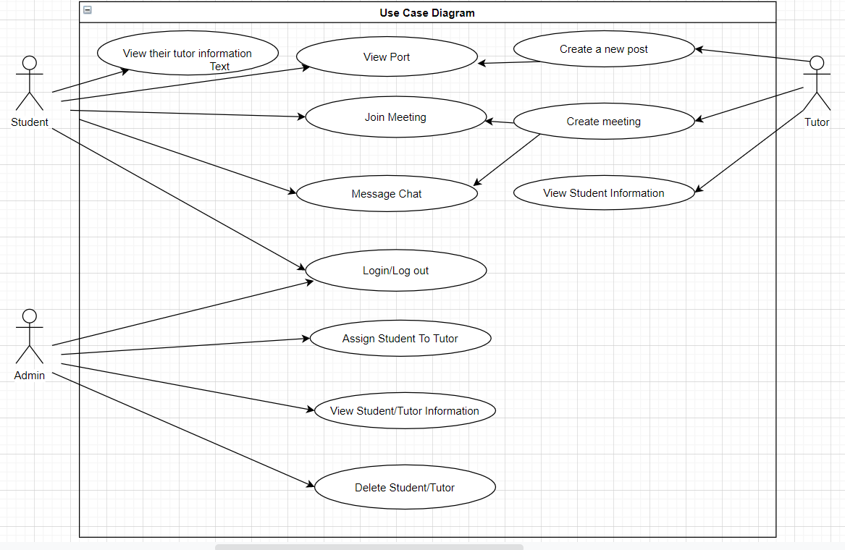

**Figure 1: E-tutoring System Use case Diagram**

This is a general outline of the features of tutor, student and admin when logging into our system. It is an important basis for us to determine the direction for our products. These features will be summarized in the section below.

## ERD

In this project, we use NoSQL instead of SQL because they bring a lot of benefits. First, we easily store data and queries. Next, we easily work with unstructured form data with NoSQL. Moreover, changing data (adding, editing and deleting) is easy and convenient, not as complicated as SQL. And finally, because of the lack of ACID of transactions and data consistency, NoSQL DB can be extended and run on many machines easily.

Because of using NoSQL Database, the data of the tables are independent of each other. Therefore, when creating a collection, we will add the necessary data without regard to other collections.

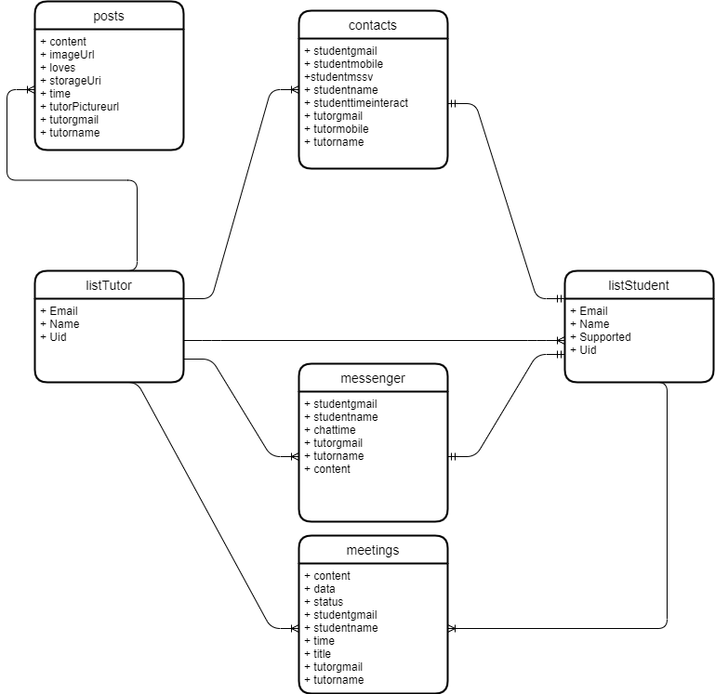

**Figure 2: ERD**

This is our ERD, we used Firebase to store data. There are 6 entities including **listTutor**, **listStudent**, **posts**, **contacts**, **meetings** and **messenger**. Firstly, listTutor entity stores information of tutor including Email, Name and Uid. Secondly, listStudent entity is similar to listTutor but it has more than one information that is **Supported**. Supported is the tutor who tutoring this student. The relationship between listTutor and listStudent is one-to-many relationship because one tutor can tutor many students but student can be tutored by one tutor.

Thirdly, posts entity is the post of tutor, it stores content (content of post), imageUrl (image of post), loves (total love of post), storageUrl, time (posted time), tutorPictureurl (picture of tutor), tutorgmail (gmail of tutor) and tutorname (name of tutor). The relationship between listTutor and posts is one-to-many relationship because one tutor can have many posts, but one post can be posted by one tutor.

The four is contacts entity, it stores information of tutor (tutorgmail, tutorname and tutormobile), student (studentgmail, studentmobile, studentmssv and studentname) and last interaction time (studenttimeinteract). The relationship between listTutor and contacts is one-to-many relationship and between listStudent and contacts is one-to-one relationship because one tutor has many contacts of students but one student has only one contact of one tutor (supported).

Next this is meetings entity, it stores information of tutor (tutorgmail and tutorname), student (studentgmail and studentname) on this meeting and meeting (content, data, status, time and title). The relationship between listTutor and meetings and listStudent and meetings is one-to-many because tutor can create more than one meeting with one student.

And messenger entity is the final, it stores information of chat between one tutor and one student including studentgmail, studentname, tutorgmail, tutorname, chattime (when content is sent) and content (content of each message). The relationship between listTutor and messenger is one-to-many relationship because tutor has many messenger (students who he supports) and between listStudent and messenger is one-to-one relationship because one student has one supported.

## User Roles

As you can see, we have broken down into 3 different user types with specific features for each role. Here I will summarize to have a more overview.

First, the admin will be able to view tutor and student details. They can assign students to tutors and can track students who have not interacted for days to take action.

For tutors, after being assigned students can view the information of the students they are assigned, can create new posts to post information and create online and offline meeting appointments with their students.

For students after logging in they can view the post of their tutors and participate in meetings and can chat with their tutors. They can also view information of their tutor

# Site Design

After identified the objects of the product as well as the functions of those objects, we got a better overview of what we needed to do. However, to be able to build a website is not enough. We need a general overview so we can have a more detailed picture of how objects are arranged, how well they are sized, etc. It makes us build the web site easier and not having to edit too much. Here are the wire frame designs for admin, tutor and their student.

The first will be the general interface design for all users. This will include the design home page, the login function into the system.

### Home Page

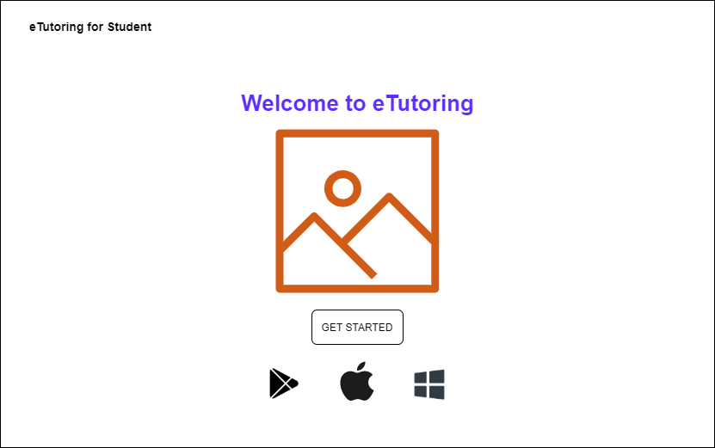

**Figure 3: Home Page**

When users access the website, the home page interface will appear, the user will click the “Get Started” button to login to his user interface. In it there will be detailed features for each person.

### Login Account:

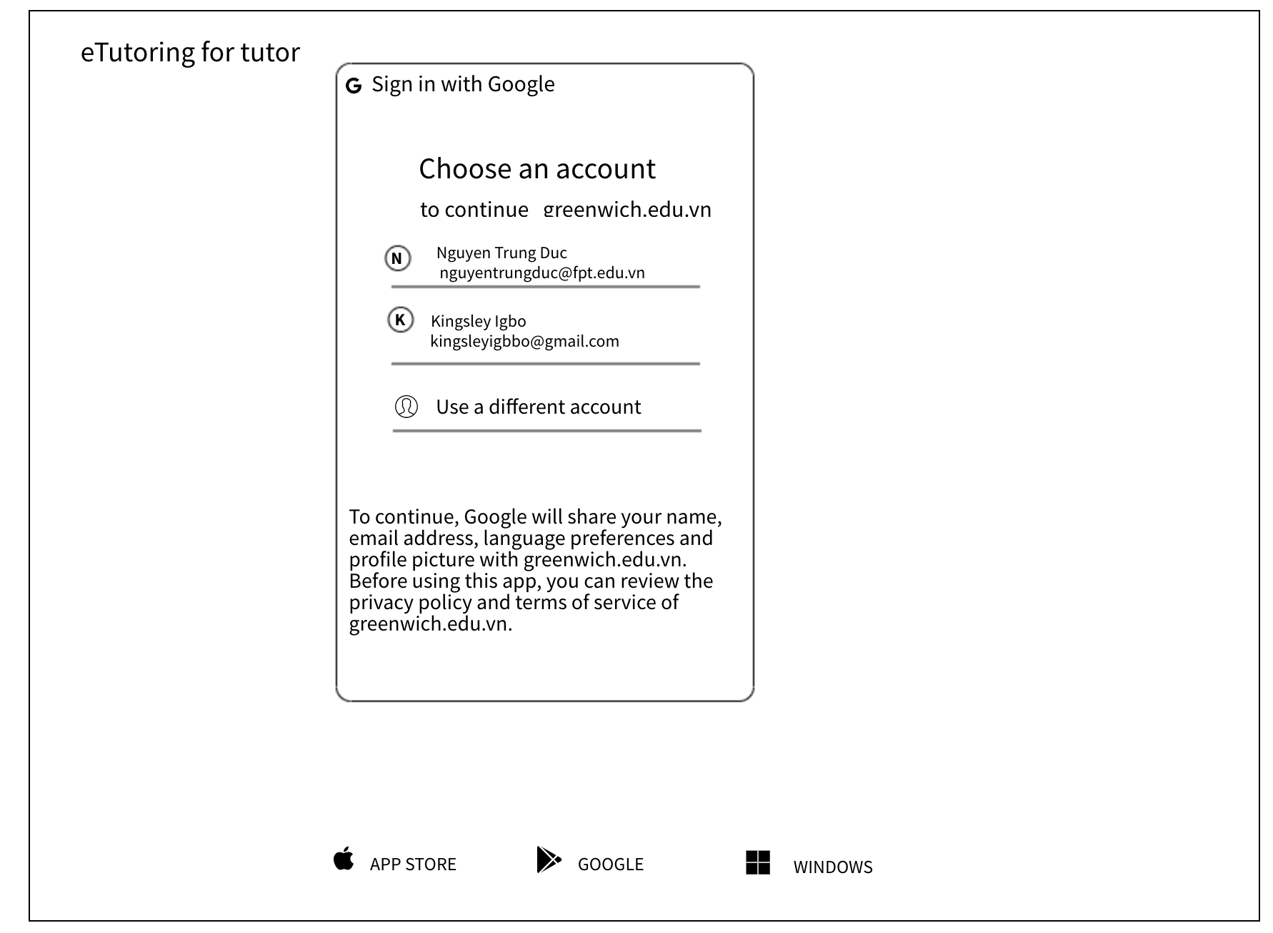

**Figure 4: Login Account**

After clicking the "Get Started" button, the website will appear Login box for users to log in with the account that they have been provided from before. After successful login, they will be redirected to the interface appropriate to their functions. In the next section, I will show the design interface for each of these functions.

## Admin Wire Frame

In the first we will start with designing wireframe for admin. In this section, I will show you the interface design as well as admin features that can be implemented when logging into the system. When the admin successfully logs in, they will see their dash board interface. In the left corner are the properties "Main" and "Extras" in which when the admin clicks on the "Dash board" button they will return to the main interface of the site. Inside "Extras" there are two buttons, "Student Statics" and "Tutor Statics". Their use will be detailed in the below.

### Admin Assign

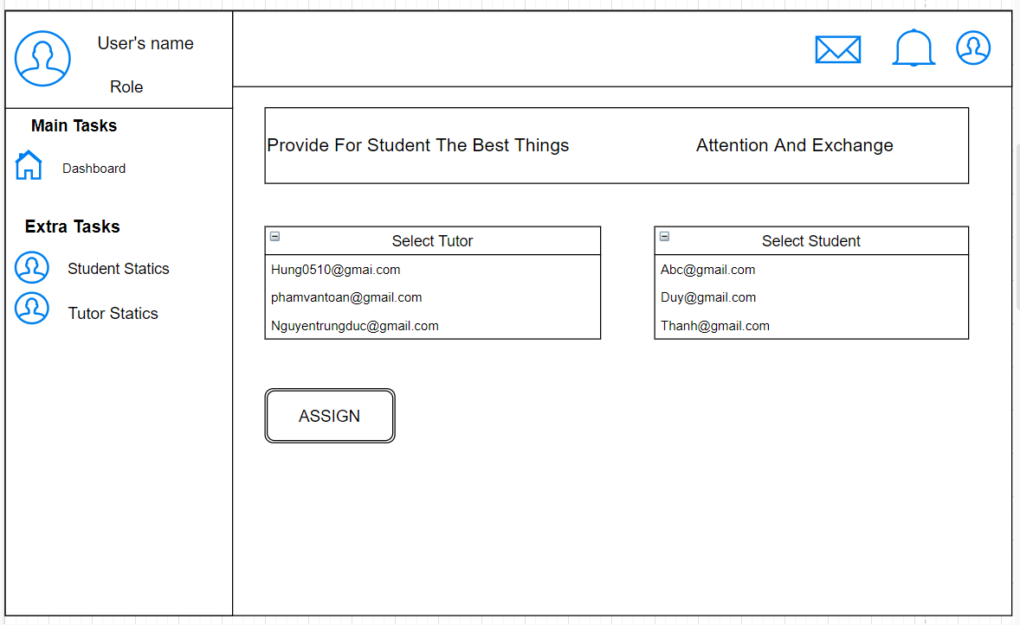



**Figure 5: Assign Students To Tutor**

After the admin has successfully logged in, they can choose students and assign them to any tutor. We have designed the website so a tutor can have many students.

Once the assignment is complete, the admin can scroll down to see if there are no students assigned to the tutor yet. In the table will also show the tutor is not enough students so admin can choose to assign students to them.

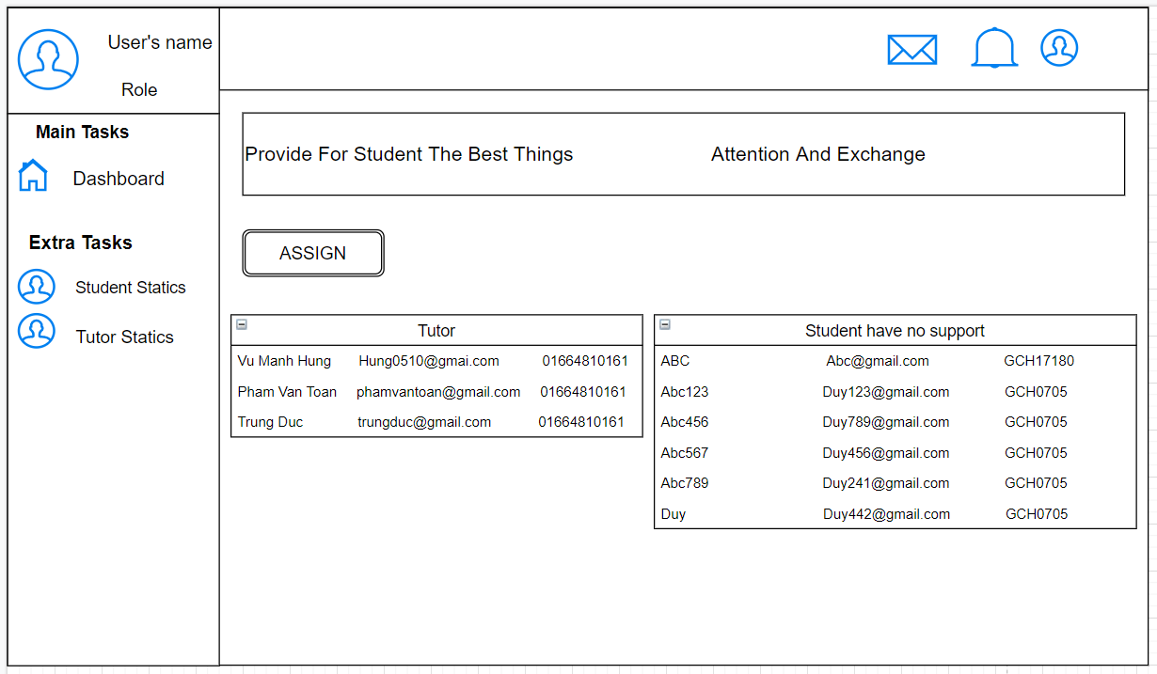

**Figure 6: View List Of Students Without Support**

### View Information Of Students & Tutor had Assign

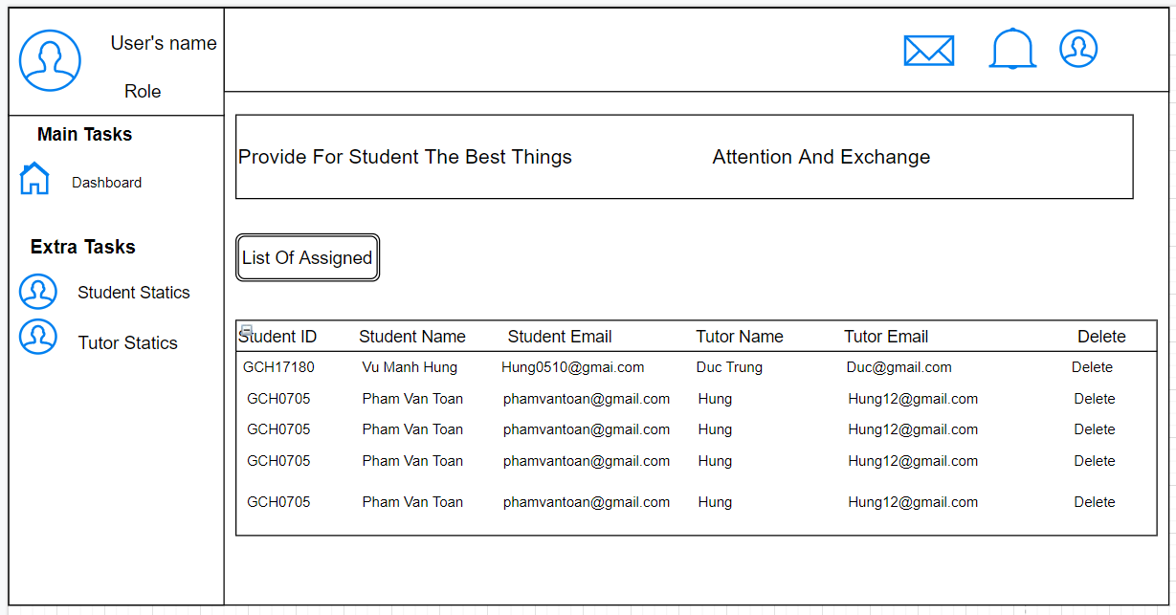

**Figure 7: View Information Of Students & Tutor had Assign**

After the student has been assigned to the tutor, the admin can continue scrolling down to see the details of the student's name, email and student code of students who have already assigned the tutor and information about their tutor. They also can click on “Delete” button to delete student out of table.

### Tutor Statics

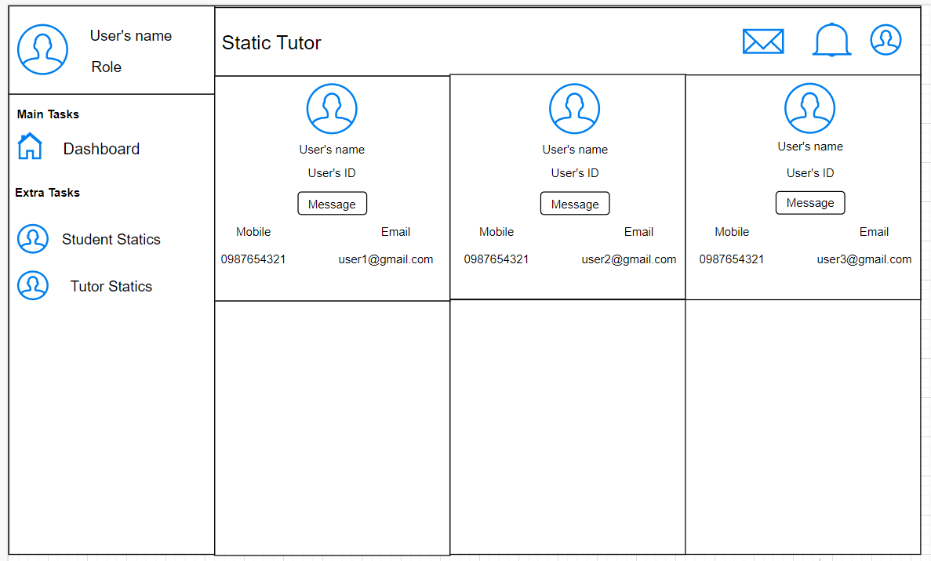

**Figure 8: View Tutor’s Information**

When Admin click on "Tutor Statics" the interface button will automatically switch to another page. Here admin can see all the details of each tutor such as email, phone number, name of tutor, etc.

### Student Statics

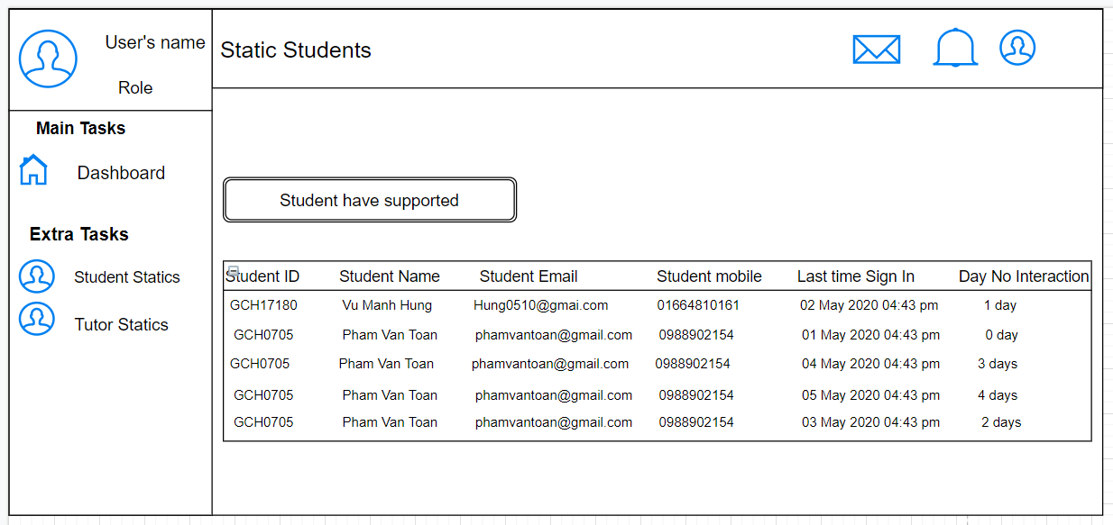

**Figure 9: View Student’s Information**

Similarly, when the admin clicks on the "Student Statistic" button they will be able to view the details of the students who have been assigned tutors as their names. student ID, email, phone. In addition, they can see how these students have been dormant for days and then identify and handle the offending students.

## Tutor Wire Frame

In the next section will be a wireframe design with the interface and functions for the user as a tutor:

### Tutor Home Page:

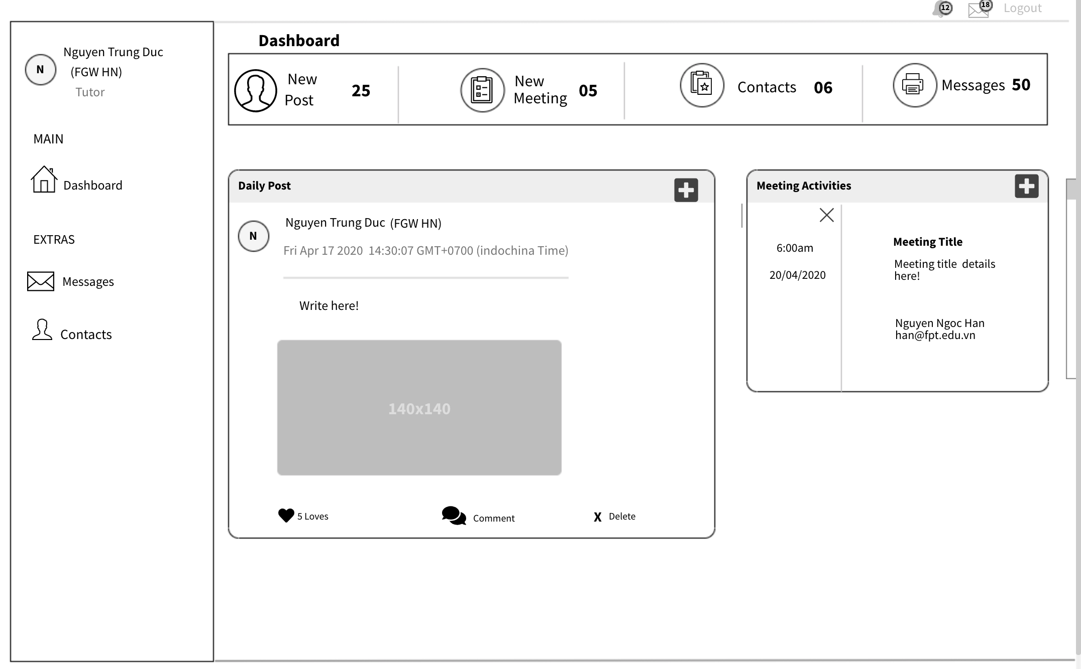

**Figure 10: Tutor home page**

If the login is successful, the tutor can access the Dashboard. On the left side of the web page will display their information including their name and role as well as their duties. Some examples when tutor clicking on the "Main" button will take you to the home page and "Extras" where containing Messages and contacts. In the upper right corner there are 3 icons representing 3 functions including "Message", "Notification" and "Log Out". Below are the meeting activities containing the title, time and date of the meeting.

Besides the meeting activities, the daily post contains news feeds, images or attachments. Below the attachment are the like, comment and delete features.

### Daily Post:





**Figure 11: Daily Post**

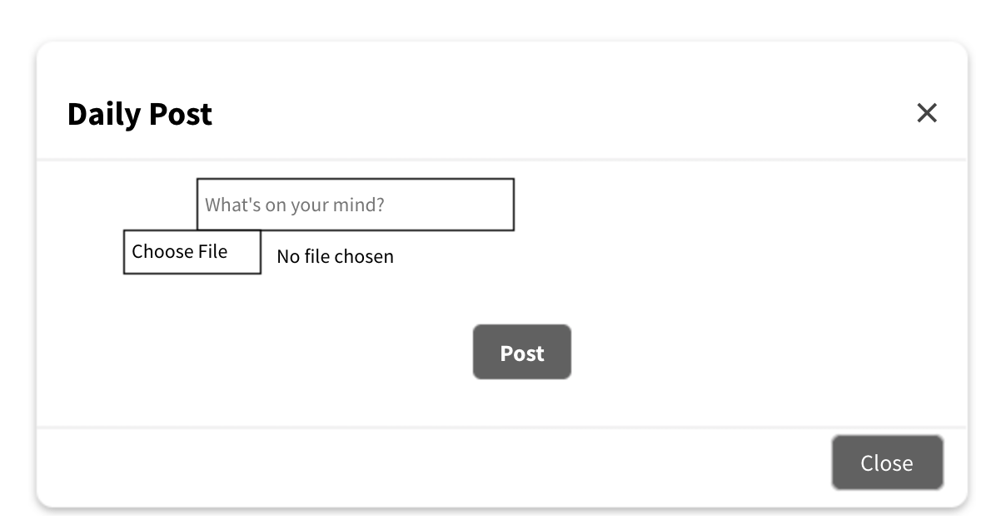

**Figure 12: Daily Post Example**

This is the interface when the tutor wants to create a new post. The top box is where the tutor writes an information and below is the "Choose File" button where tutor selects a file from the local storage device that could be an image. If no file is selected, it will display "No file chosen" to prompt the user to select a file. And a button below "Post" to post information to the group. At the bottom right is a "Close" button to exit the form when the tutor finishes the work.

### Create New Meeting:





**Figure 13: Example Of Create New Meeting**

The plus (+) icon on the right side of the meeting activities signifies creating a new meeting. When tutors want to make an appointment with their students, they just need to click the plus sign to create a new meeting.

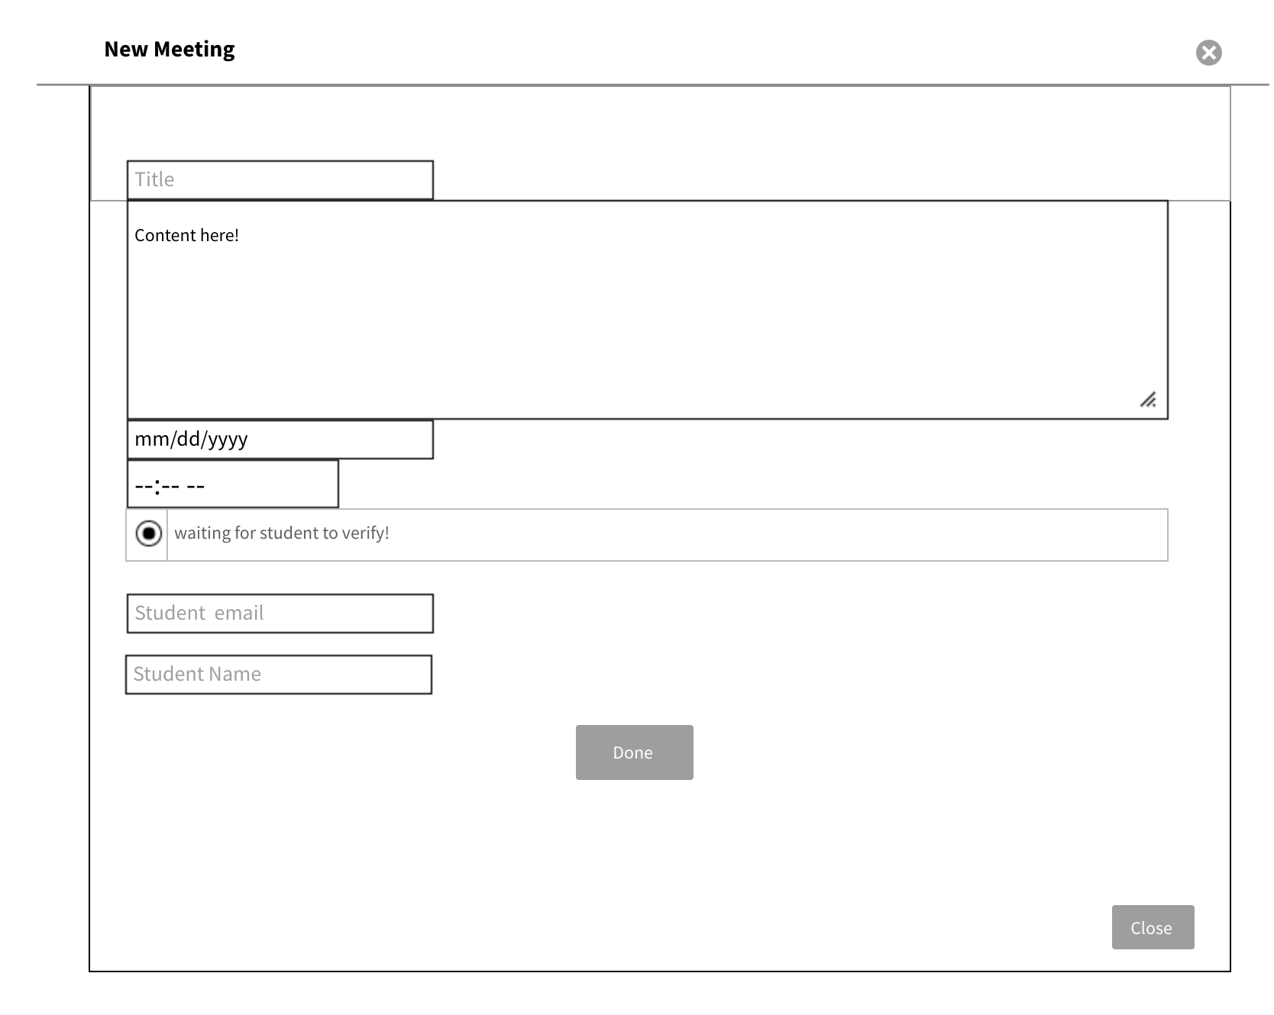

**Figure 14: Example Of Create New Meeting**

This is the form to create a new meeting. At the top is the "Title" button where the tutor enters the title of the meeting. Below is where the tutor enters the content for the meeting. Below the content is a date picker in which the tutor can choose month, day and year. Next is the time. The tutor can choose how long the meeting will last. Next is the radio button that the tutor clicks while waiting for the student to verify. The two sections below are the email and student name with a button that will send the meeting information entered into the meeting activity in the control panel. Finally, a close button at the bottom right to close the page.

### Tutor Contacts:

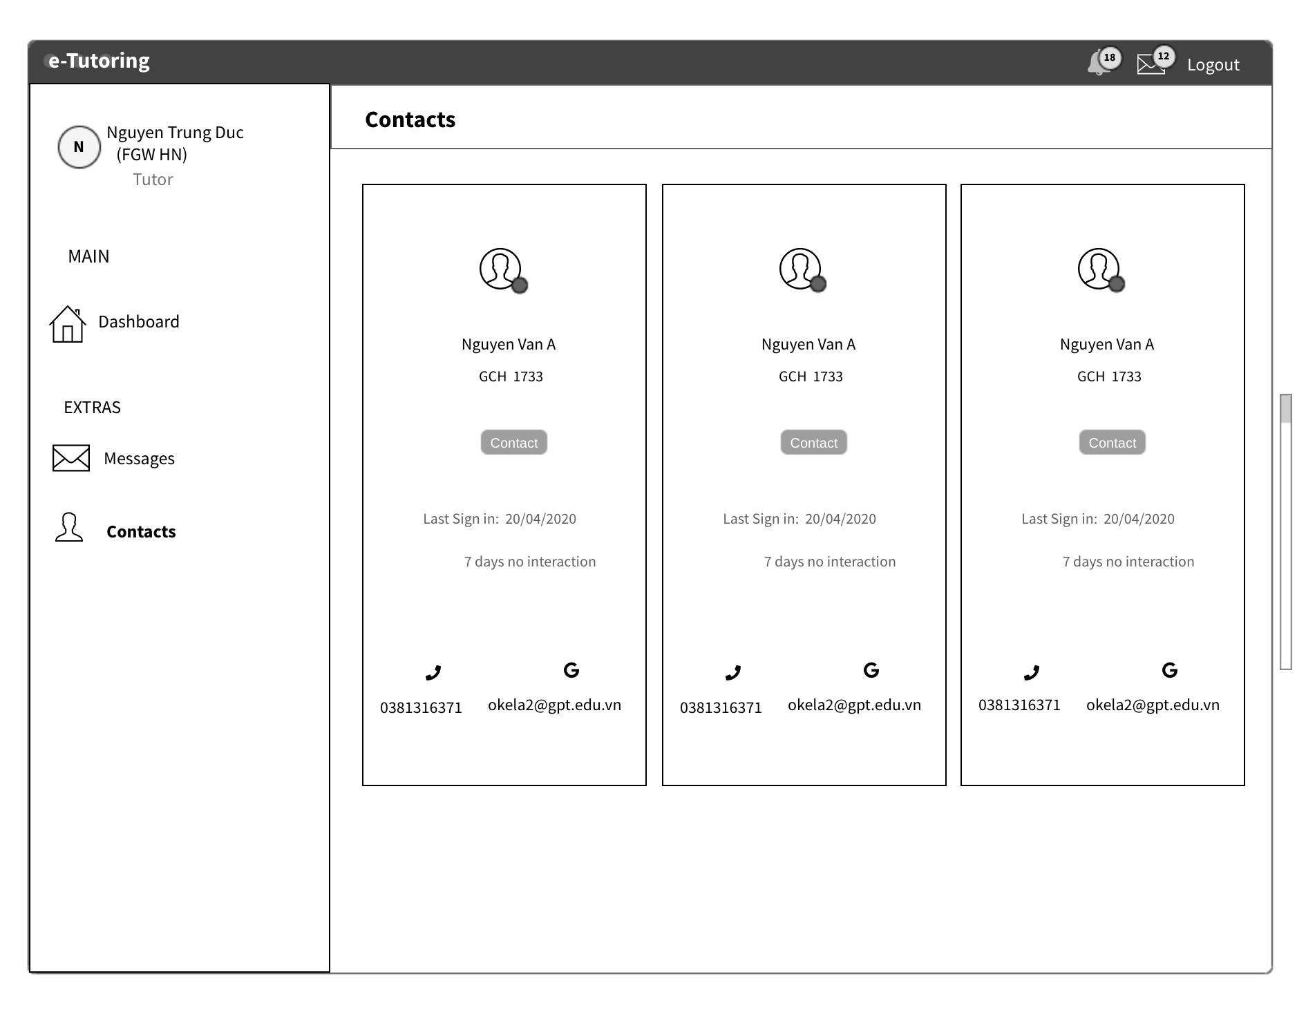



**Figure 15: Tutor Contacts**

When Tutor clicks the "Contact" button on Extra, it displays the contact between the student and their tutor. In the contact information, there are 4 information including: "User name", "User ID", Phone number of user "and" User email ". In addition, there is a message function to chat with this user.

### Tutor Messages:

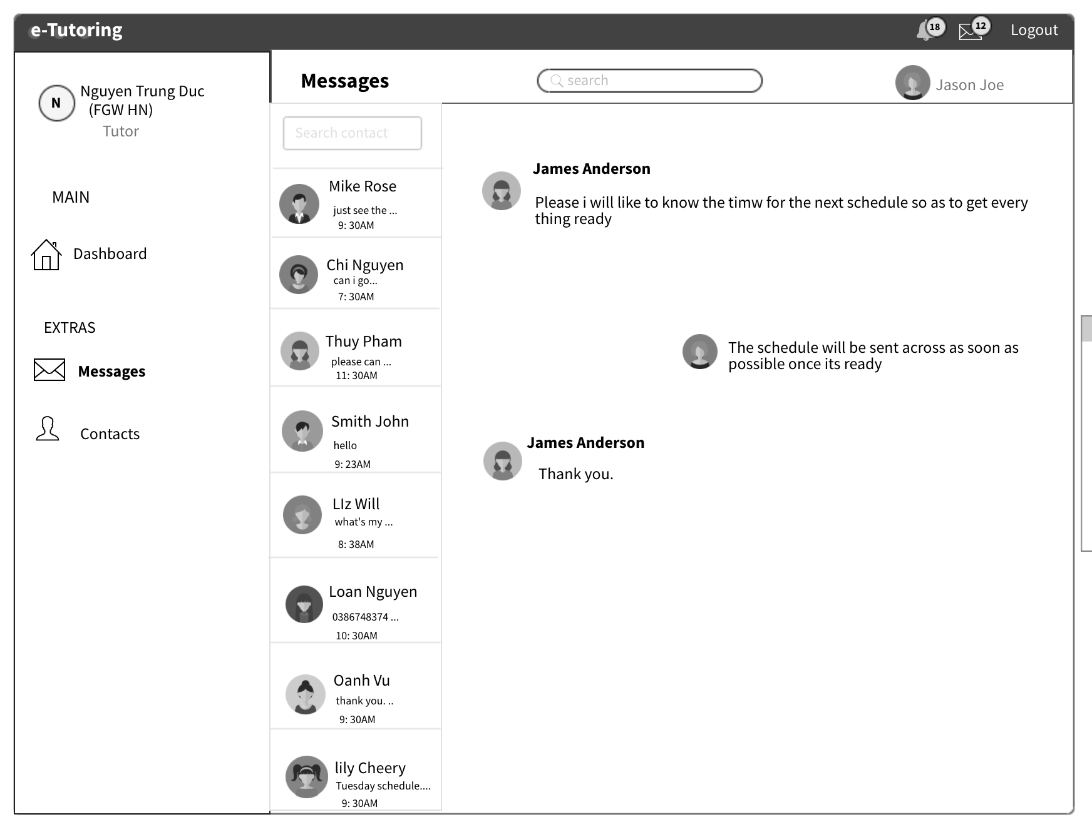



**Figure 16: Tutor Messages**

When the user clicks the "Message" button on the Extra, it displays the chat page where the tutor can exchange information with their students through the message. Display student contact with a preview of the message and the time of the message. "Content" is where the tutor writes the message and click on the arrow icon to send it to the student.

Above is the entire Wireframe design interface and tutor features. In the next section we will show the Wire frame design about the interface as well as the features of Student.

## Student Wire Frame

In this section, I will show you the design of the interface and features of students when using the system.

### Student Dashboard

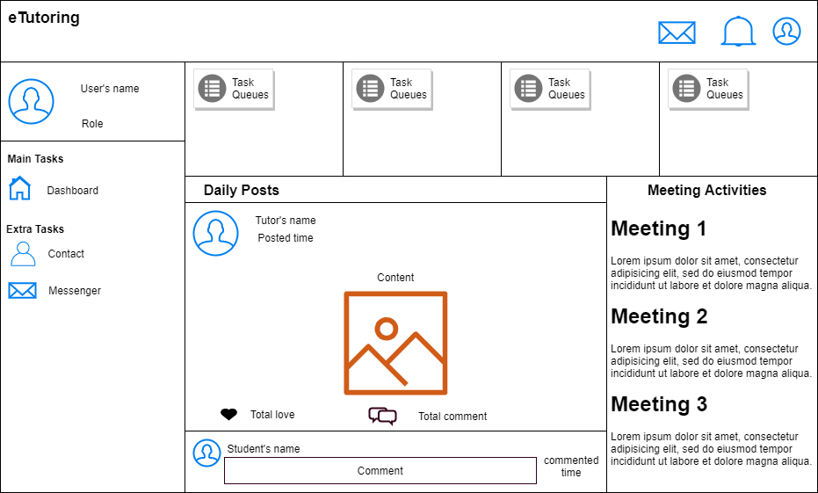

**Figure 17: Student Dash board**

After login successful, students will access the **Dashboard** on **Main Task**. On the left of website, there are their information including name and role and their tasks including **Main Tasks** and **Extra Tasks**. In the upper right corner there are 3 icons representing 3 functions including **messages**, **notifications** and **personal information**. Right below is the main information of the page including **student tasks**, **daily posts**, and **meeting activities**. In daily posts, it will show the posts of their tutor, they can view, love and comment. In meeting activities, it will show the meeting between student and their tutor.

### Student Contact

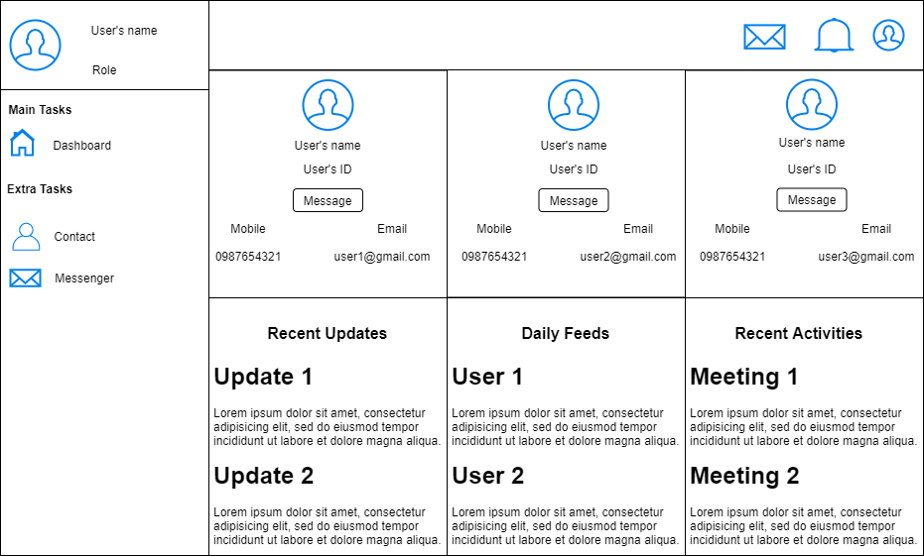



**Figure 18: Student Contact**

When student click on the "Contact" button on Extra Tasks, it will show the contact of their tutor. In contact information, there are 4 information including "User’s name", "User’s ID", "User’s mobile phone" and "User’s email". In addition, there are a function is "Message" to chat with this user.

### Student Message

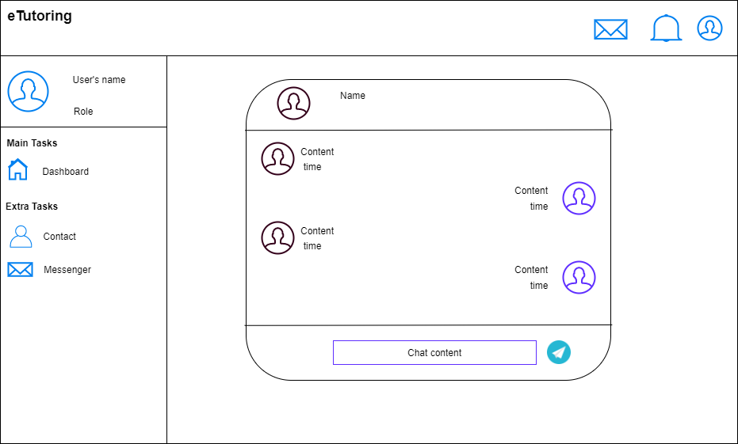



**Figure 19: Student Message**

Finally is "Messenger" button. When student click on it will show the chat between student and their tutor. In chat interface, there are 4 information: "Name of tutor", "Name of student", "Time when chat sent" and "Chat content". The plane paper icon is the send button to send chat content.

# Product Review

In the next section, I will show you the detailed and realistic images of the system that we have built and give specific examples of the functions of each user.

## Functional Requirement

A system needs functions to meet the needs of the user. A must-have function for a system is the login function. This function is necessary because it protects the user's personal information as well as protects the data for the system. With the system we are building, we want to make it convenient for users, as they do not need to waste time on account registration. They can use google account to login to the system. In this section we will analyze why we use authentication by google API explicitly.

### Authentication by Google API

The system we are building needs to know the identity of the user. This allows the system to store user data in the database. With a specific identity the system will fetch specific data for each user and display it. With the firebase platform that the system is using, firebase authentication provides ancillary services, easy-to-use SDKs and ready-made UI libraries. This helps authenticate users to the system, and our most popular link choice is Google.

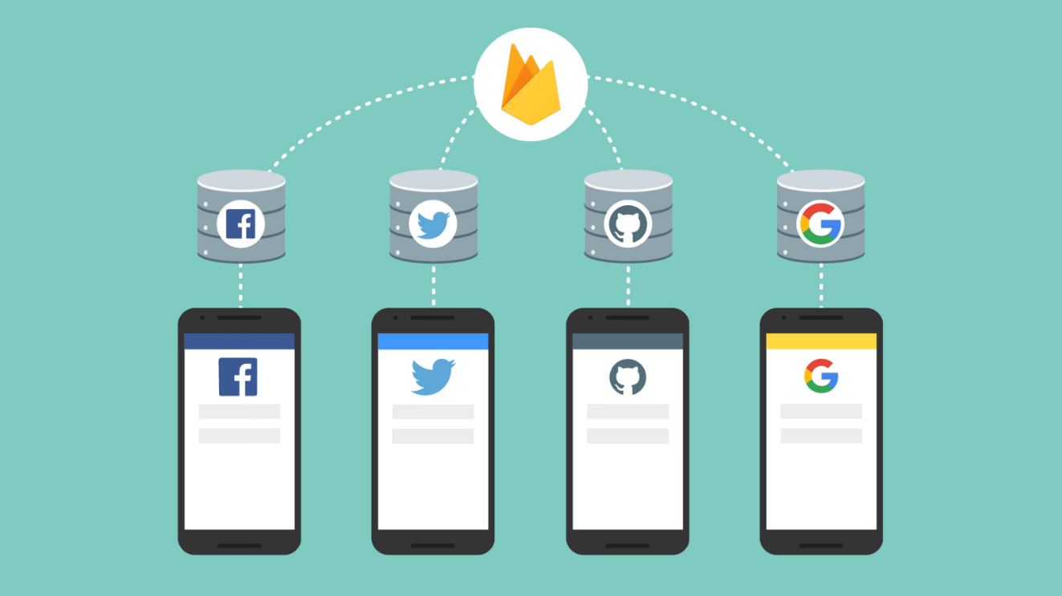

**Figure 20: Federated identity provider integration**

(<https://firebase.google.com/docs/auth>)

By using Firebase SDK authentication, login method will be added to the system. Authenticate users by integrating a google link identification provider, and allow users to log in with a Google account.

### Firebase Authentication on Websites

Users use Google accounts to log in to the system. To do this, need to integrate Google Login using the Firebase SDK. Firstly, I activated Google login in Firebase control panel.

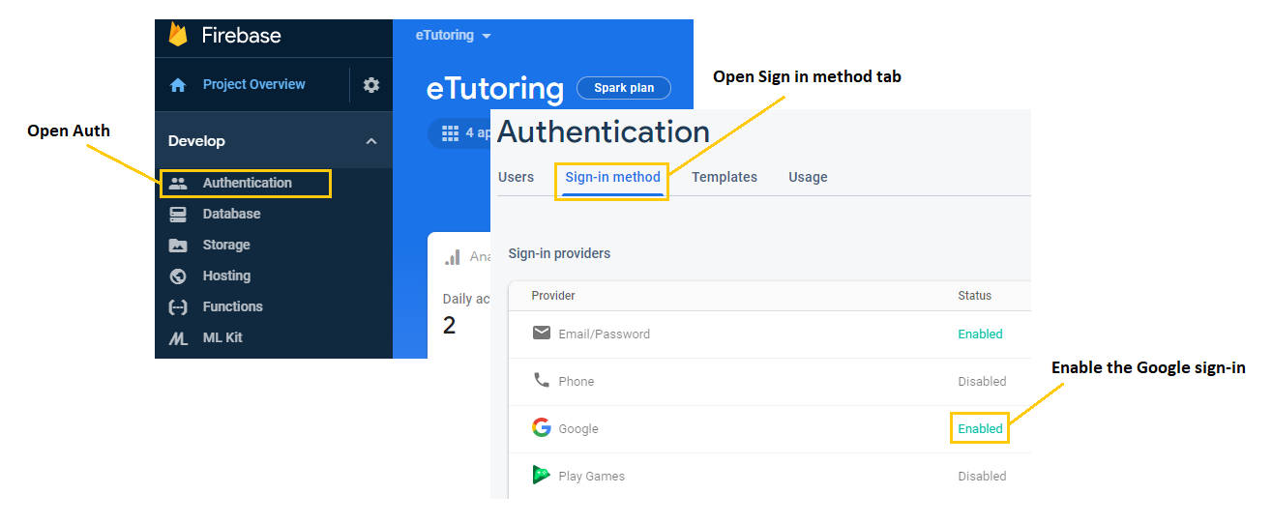

**Figure 11: Enable the Google sign-in**

The next step is to handle the login flow to handle I have used JavaScript in the following way. (Figure 22) In the first lines of code create a version of the Google provider object, followed by the second line of code validating using the Google provider object a popup window for users to log in with a Google Account there.

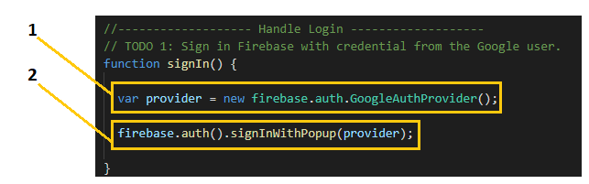

**Figure 22: Handle the sign-in**

## Admin Interface

After the admin has successfully logged in, they can choose students and assign them to any tutor. We have designed the website so a tutor can have many students.

Once the assignment is complete, the admin can scroll down to see if there are no students assigned to the tutor yet. In the table will also show the tutor is not enough students so admin can choose to assign students to them.

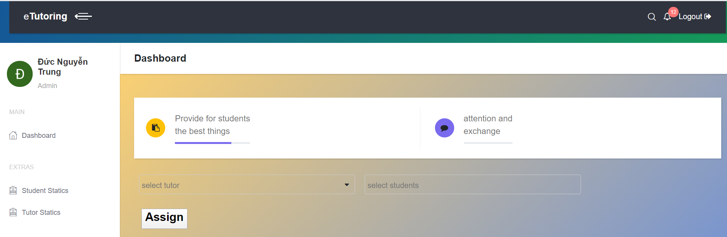

**Figure 23: Assign Student To Tutor**

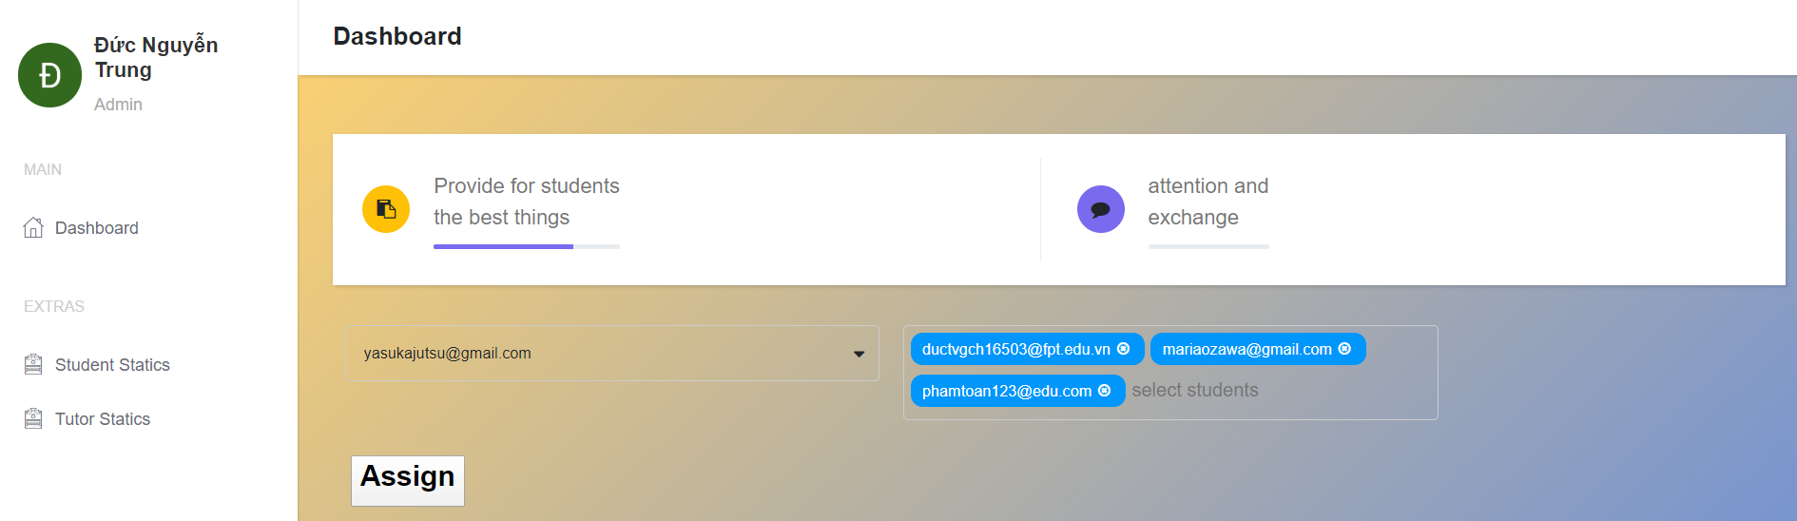



**Figure 24: Assign Student To Tutor**

As you can see, the admin can choose one tutor and assign multiple students to the tutor at the same time as long as the number does not exceed the allowed limit.

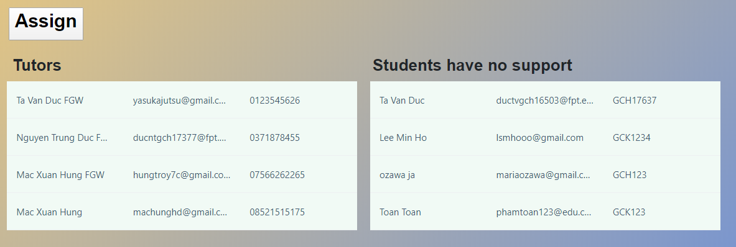

**Figure 25: View Student Information Without Support**

After finishing the assignment, when the admin scrolls down, you will see a list of students who have not been assigned a tutor.

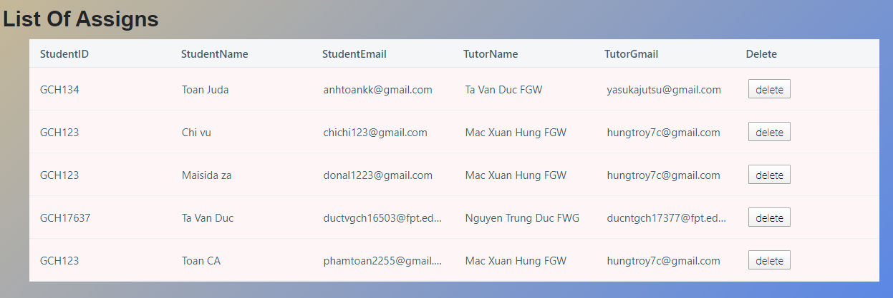

**Figure 26: List Of Assigned**

As shown above when designing wire frames, administrators will be able to see the information of assigned students and their tutors. When the admin clicks on the "Delete" button, The student will be delete of the table.

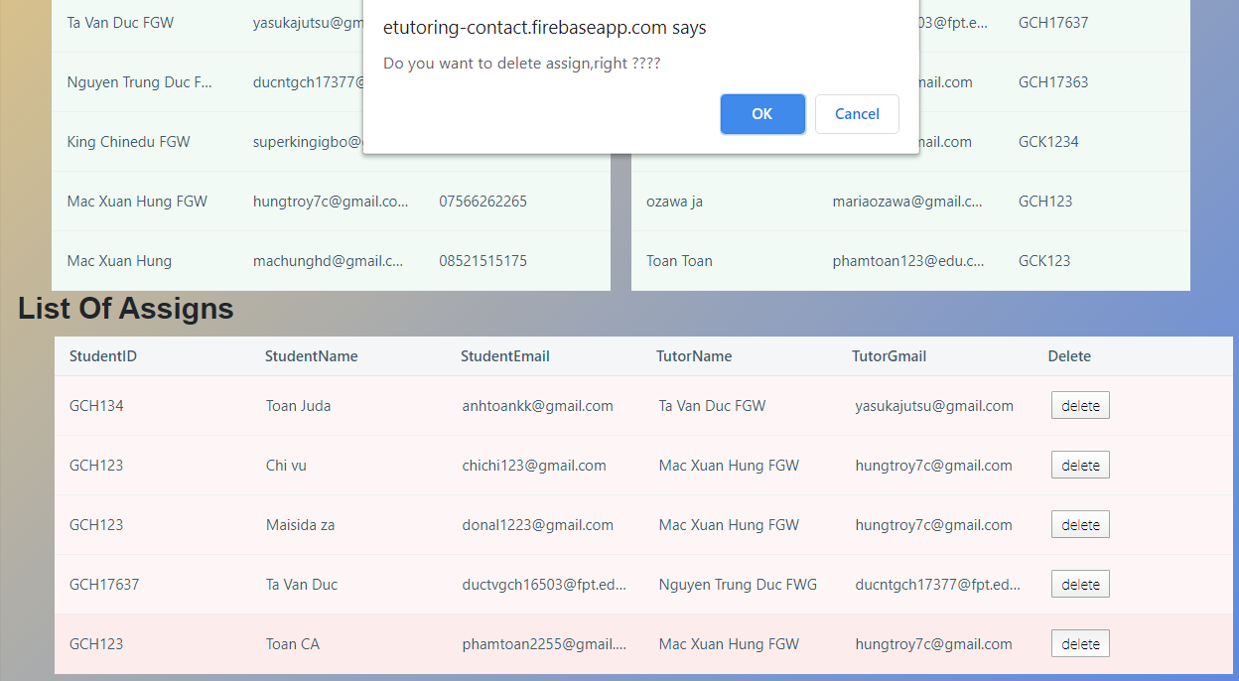



**Figure 27: Delete Student**

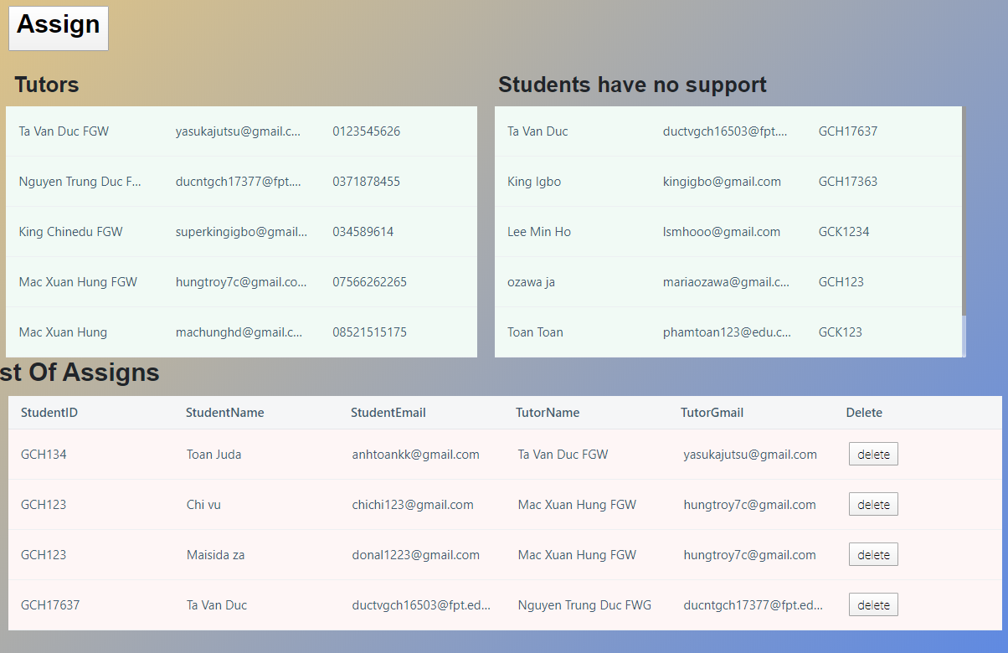

**Figure 28: Delete Successfully**

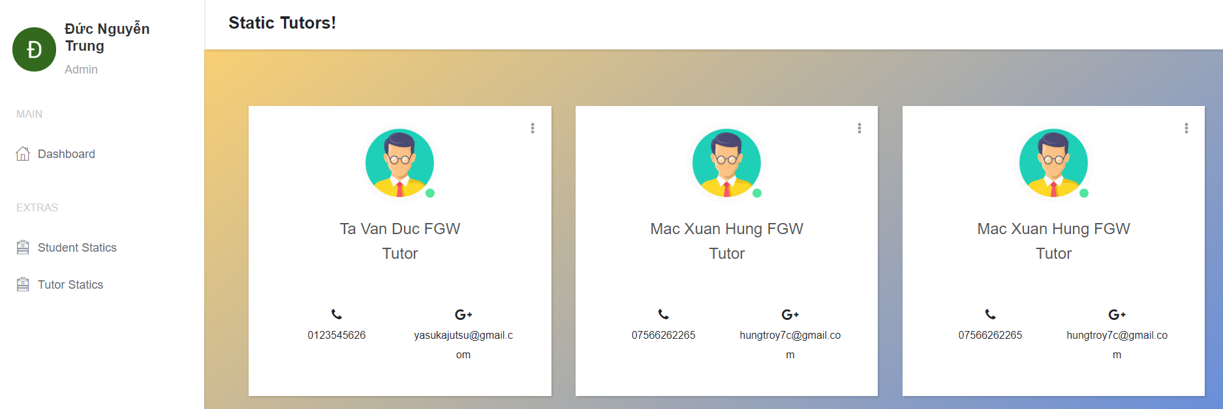

**Figure 29: View Tutor Information**

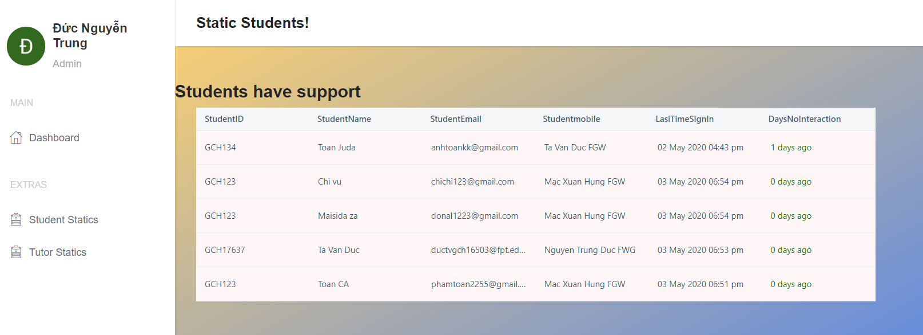

**Figure 30: View Student Information**

## Tutor Interface

As a Tutor, you will have functions that include creating meetings with students, creating posts, communicating with students.

### Meeting

The first is the meeting, the image below is the interface of meeting activities, it is located on the right of webpage. The list of created meetings will appear below, once the meeting has been confirmed by the student, the plane paper icon will change to like icon. Tutor can also delete the meeting by clicking the X mark. In the upper right corner, plus icon is used to create meeting.

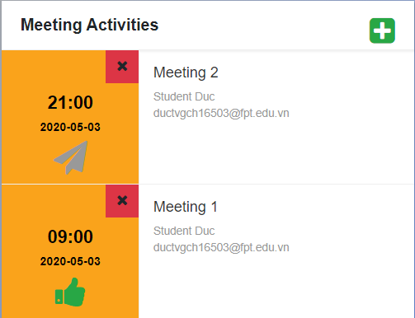

**Figure 31: View meeting**

After click on it, a creating meeting popup will be show. A meeting consists of 6 information: title, content of meeting, date, time, email and name of student. The meeting will be created after the tutor clicks “**Done!”** Button. If tutor want to stop creating the meeting, the tutor can click the “**Close”** button or the X mark in the upper right corner.

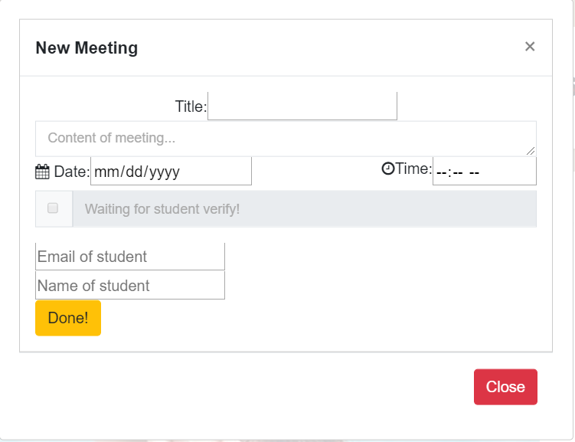

**Figure 32: Create a new meeting**

### Post

The next is Post, it is located on the middle of webpage. Similar to meeting, to create a new post, tutor must click on plus icon in the upper right corner. Tutor can also delete the post when click on Delete button. Tutor can view other tutor’s posts but they can’t delete it. Moreover, tutor can love and comment the post.

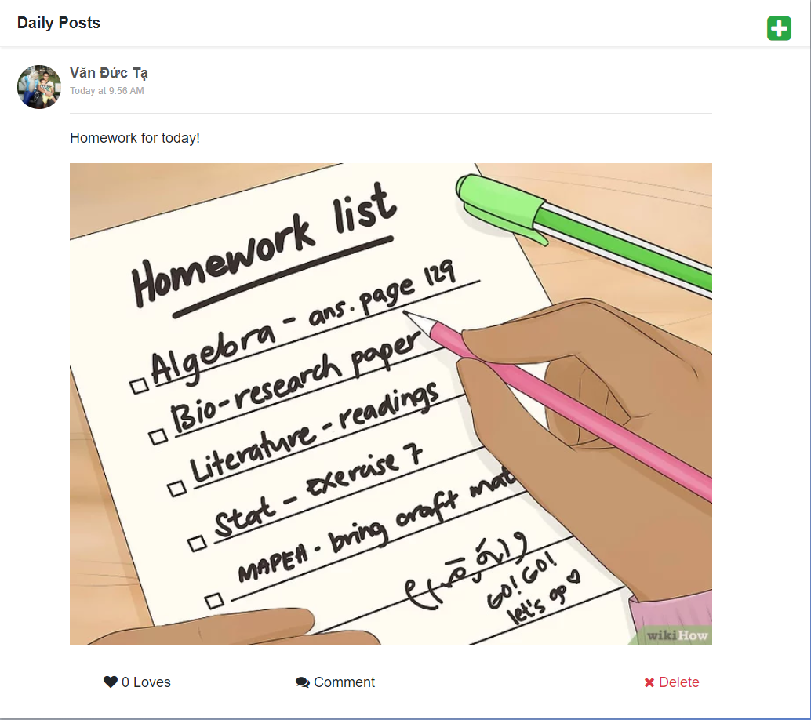

**Figure 33: Daily Posts**

Tutor can comment and view other comments by clicking in **Comment** button. To return to post, tutor need to click on **Back** button. Moreover, tutor can delete their comment by clicking on red X mark.

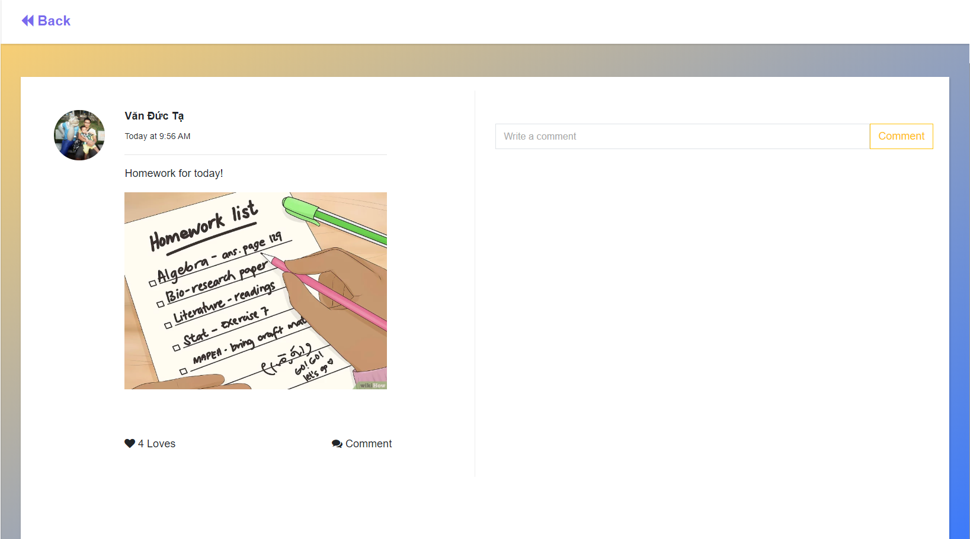

**Figure 34: Comment in the post**

In creating post popup, tutor can write content, upload image and post the post. If tutor want to stop creating the post, tutor can click the **Close** button or the X mark in the upper right corner.

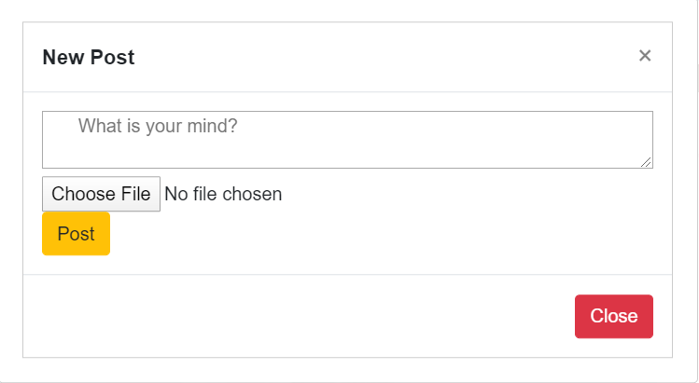

**Figure 35: Create post popup**

### Contact

**Contacts** task is located on the menu bar. In contacts task, information of this tutor’s students will be showed in there including name, student code, mobile phone, email and last interaction. Moreover, tutor can chat with student by clicking the Contact button in the middle of information table or choose **Messages** task.

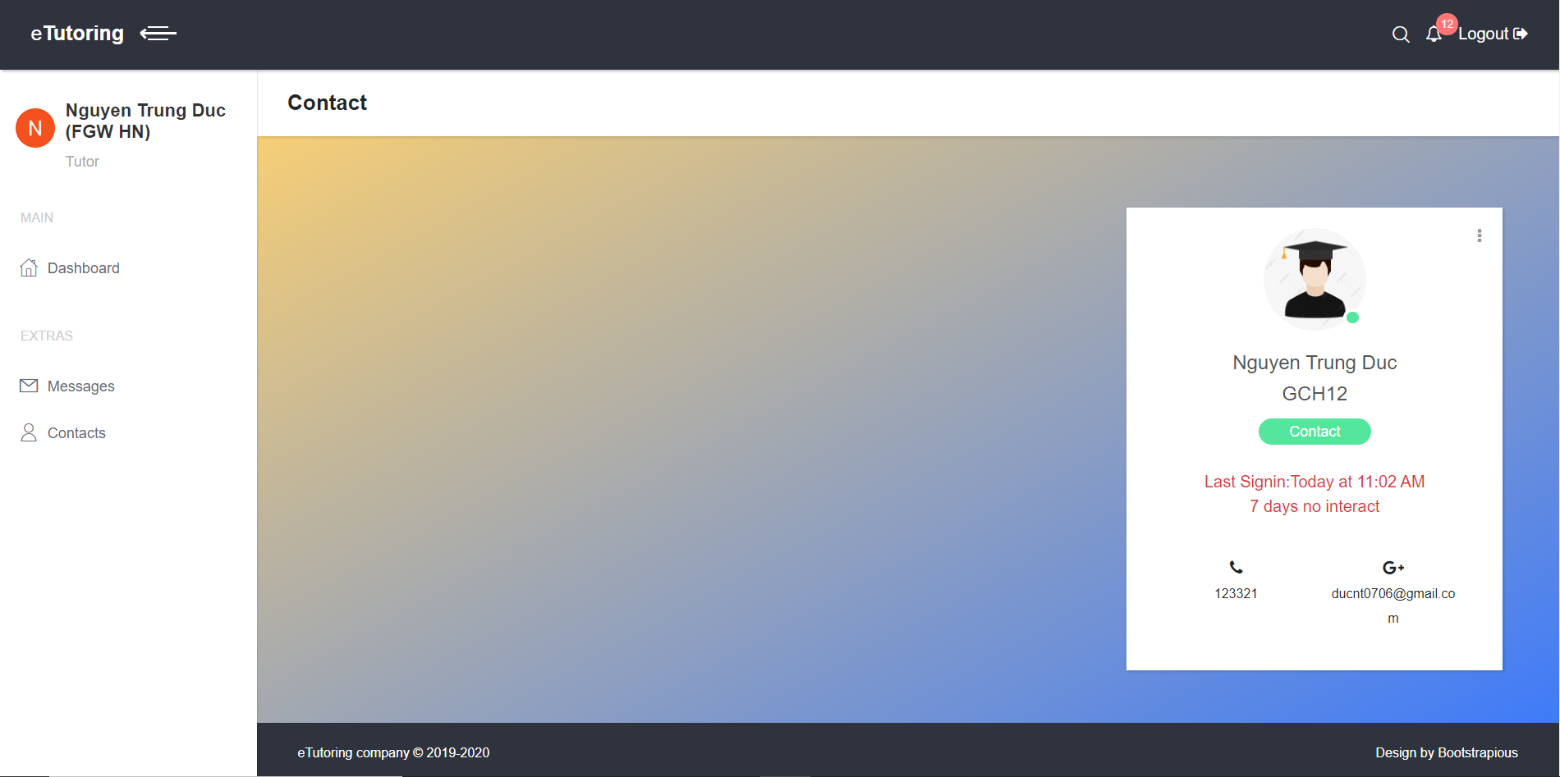

**Figure 36: View Student Information**

### Message

This is the interface of **Messages** task it consists list of student and messages box. Tutor can send message to their students. In the messages box, tutor can delete their sent message by clicking the X mark in the right of this message.

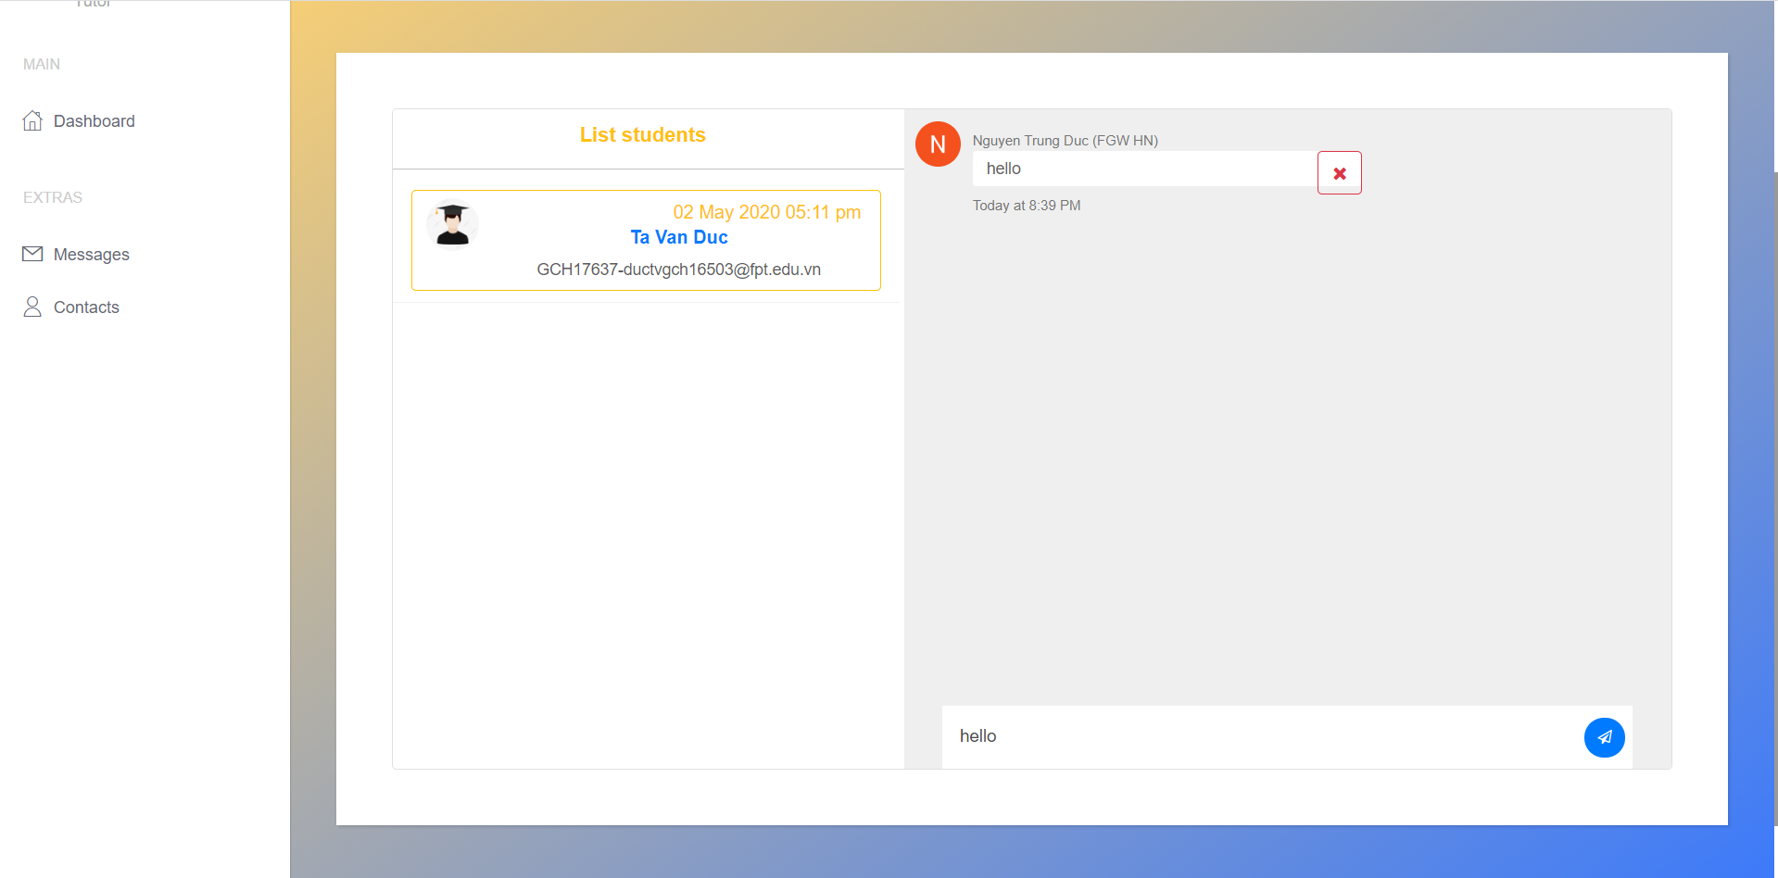

**Figure 37: Chat with their student**

## Student Interface

As a student, you will also have functions that relate to meeting, post and contact but it has some difference with tutor. The interface of student website is similar tutor’s interface.

### Meeting

The first is the meeting, students can’t add and delete meeting but can confirm the meeting. To confirm meeting, student need click on red check icon, after meeting is confirmed, the plane paper icon will change to like icon.

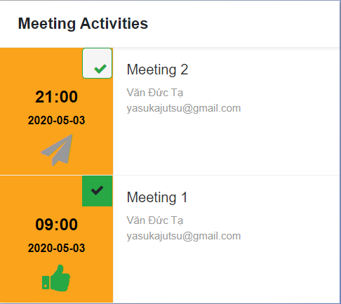

**Figure 38: Meeting Active**

### Post

The next is Post, students have less functions than tutor, they can only love and comment their tutor’s post. It’s mean they don’t have creating and deleting meeting.

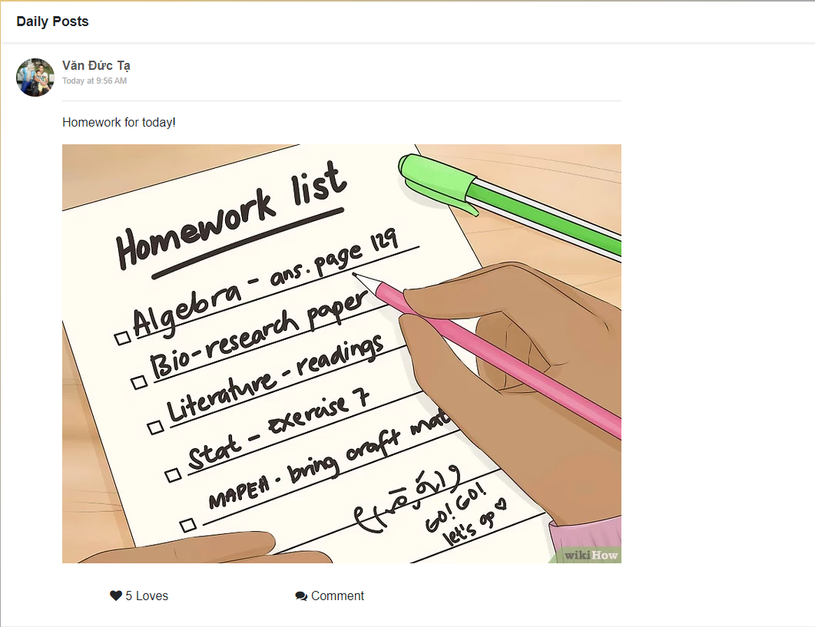

**Figure 39: Daily post**

To comment and view other comments, student need to click on **Comment** button. To return to post, tutor need to click on **Back** button. Moreover, student can delete their comment by clicking on red X mark.

### Contact

In contacts task, information of this student’s tutor will be showed in there including name, mobile phone, email and position. Moreover, student can chat with their tutor by clicking the Contact button in the middle of information table.

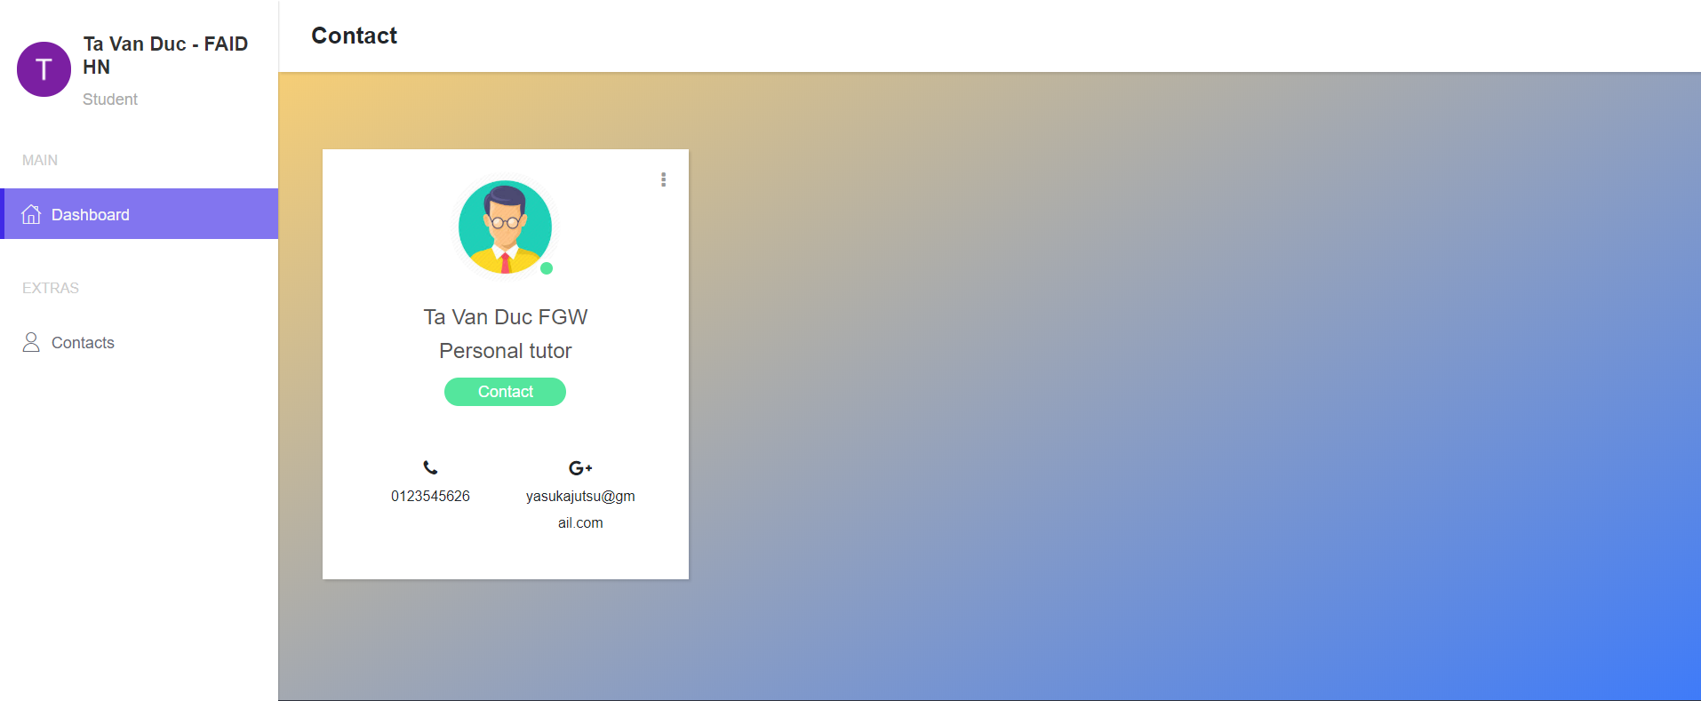

**Figure 40: View Student Information**

This is the interface of **Messages** task it consists only the messages box because student has one tutor. Therefore, student can only send message to their tutor. In the messages box, student can delete their sent message by clicking the X mark in the right of this message like tutor.

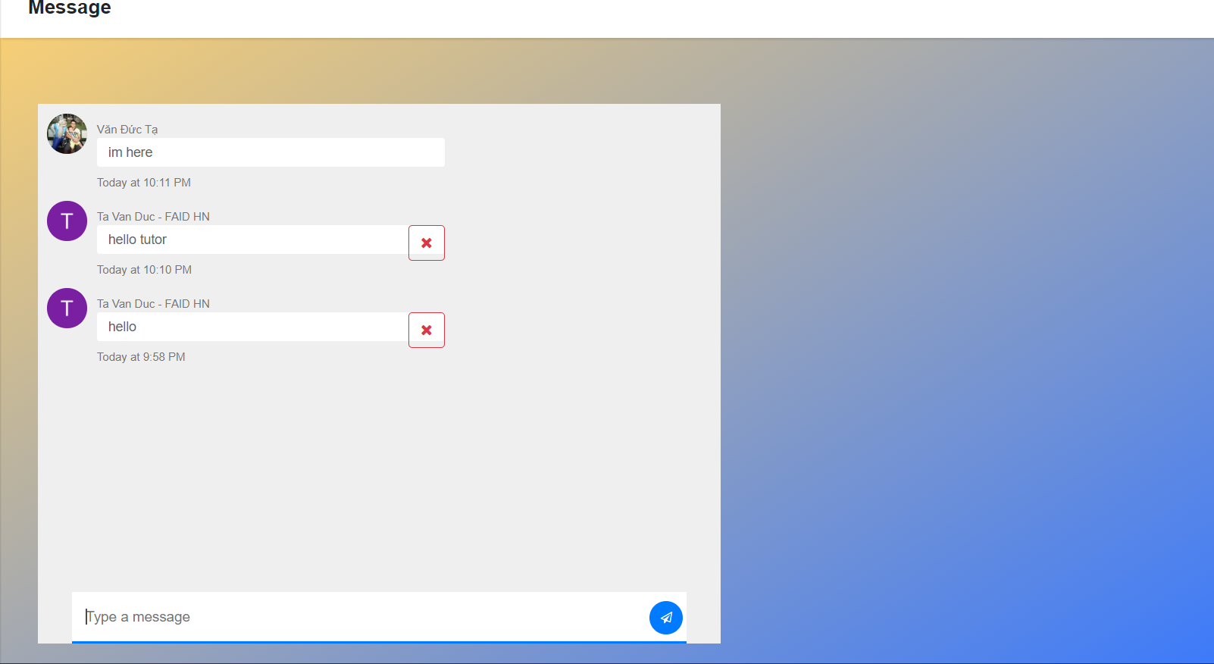

**Figure 41: Chat with tutor**

## Non-Functional Requirements

### Security

### Firebase Realtime Database Rules

Firebase Realtime Database Rules help determine who will read and write access to the system database. This job will be executed automatically continuously, all requests (read, write) will only be done when rules allow. This protects the system database from hackers and from being abused. By default, the system's database rules require Firebase Authentication and only grants full read and write permissions to the authenticated user.

Information includes their unique identifier (UID) as well as associated account data (Figure 42). Will be stored in the auth variable when the user authenticates. By combining Firebase Realtime Database Rules language with authentication information users the system can be able to control access to data based on user identity.

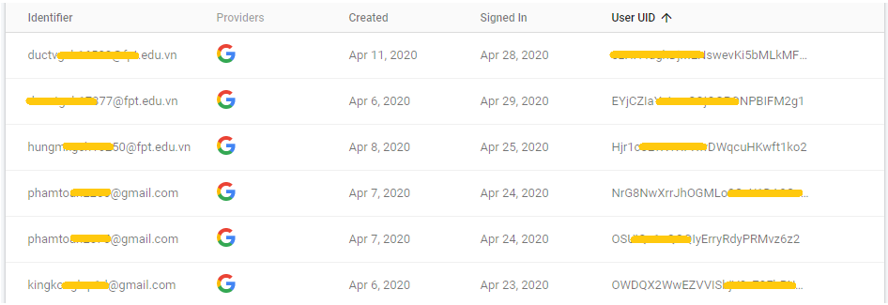

**Figure 22: User identity**

This is an example of how we use the auth variable to ensure that each user can only write to their specific path and cannot write to other users' data.

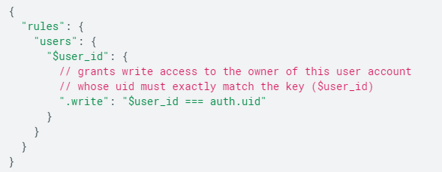

**Figure 43: Grants write access**

### Firebase Security Rules for Cloud Storage

Similar to Database Rules, security is one of the most complex parts of system development. Authentication (who the user is) and authorization (what the user can do) are hard work. To make it easier, I used Firebase Security Rules for Cloud Storage, which made it easier for me to authorize users and validate requests. With this rule it will help me complete the complex processing.

For the example shown in (Figure 44), this system always requires the default Firebase Authentication to perform any read or write operation on all files.

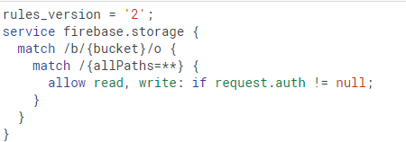

**Figure 44: Rules for Cloud Storage**

### Clean Code

The more webpage and functions are created, the more code is written; therefore, our code will be very troublesome if not neatly organized.

Regarding how to organize the code, I break down my code into as many parts as possible. First I will divide it into three main directories consist **admin, student and tutor**. In each directory, I store all the code related to that object and divide their function into separate code directories.

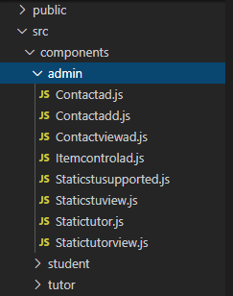

**Figure 45: Directory code**

Each code directory has only one function and no more than 50 lines of code. Therefore, each code directory is very brief, clear and feels comfortable for readers.

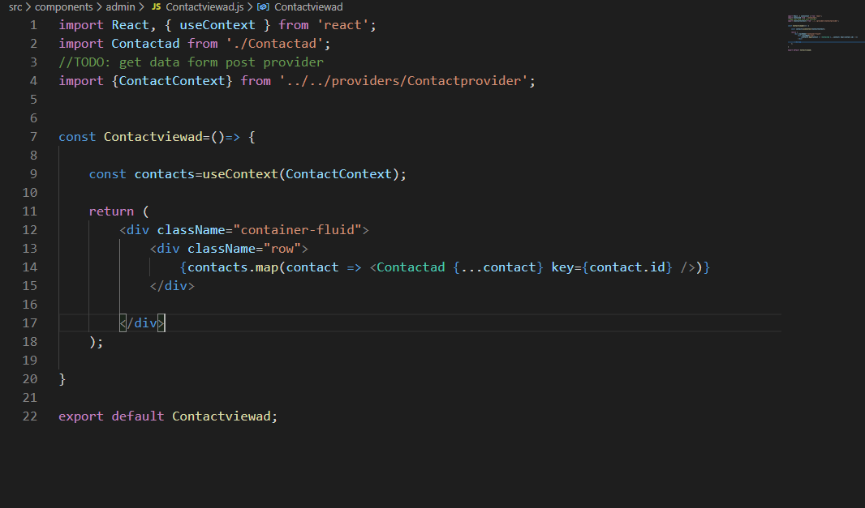

**Figure 46: Detailed directory code**

## Code Snippets

In this project, we use 3 main libraries and frameworks including reactjs for front-end, firebase for back-end and packages management by nodejs. Firstly, the website interface is built on the component class model of reactjs. This means that the site will be broken down into smaller elements such as the navbar, sidebar, meeting group, and so on. This not only improves the performance of the website, but also makes it easy for programmers to manage the project code.

**MVC Structure of website:**

We use the main language to build websites which is react according to MVC model with slight variation. However, the concept of MVC remains the same. Accordingly, the web application is divided into three main components Model, View, and Controller. However, as I said above, the names of these components will be changed, but the content will remain the same.

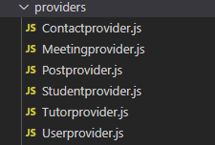

Model folder

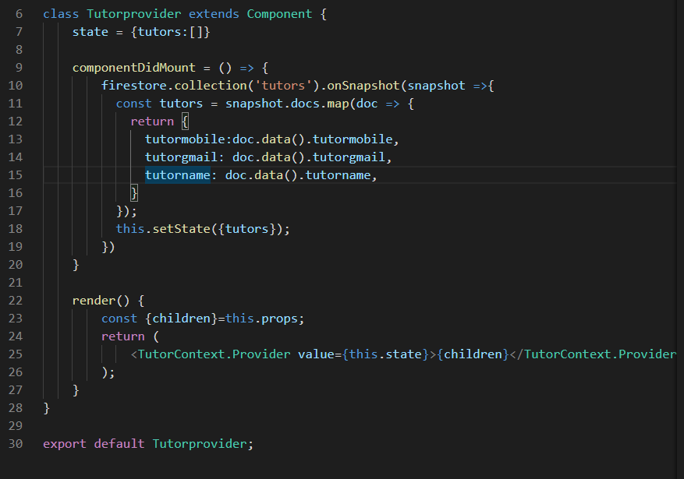

Provider Model

Similarly, the next component of the project is View, but in react, we call it screens, screens are user interfaces, or in other words it is the interface between providers and routes (Controller). There is a small change here, the screens will be divided into smaller components called components, this helps the code to be clean and increase the performance of the application.

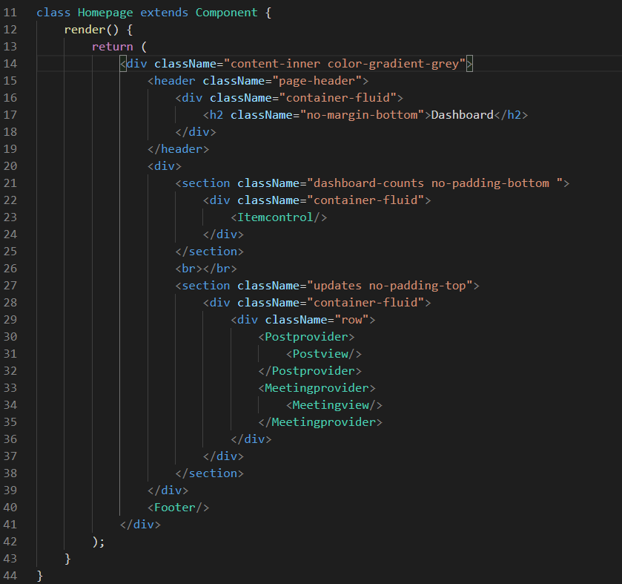

Screen example (View)

Finally, the routes class corresponds to the controller. The routes handle requests from the user to render the appropriate interface. Besides, it also manipulates data model (screen).

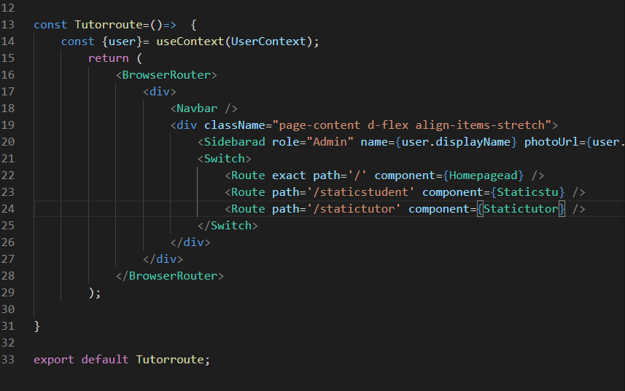

Route example (Controller)

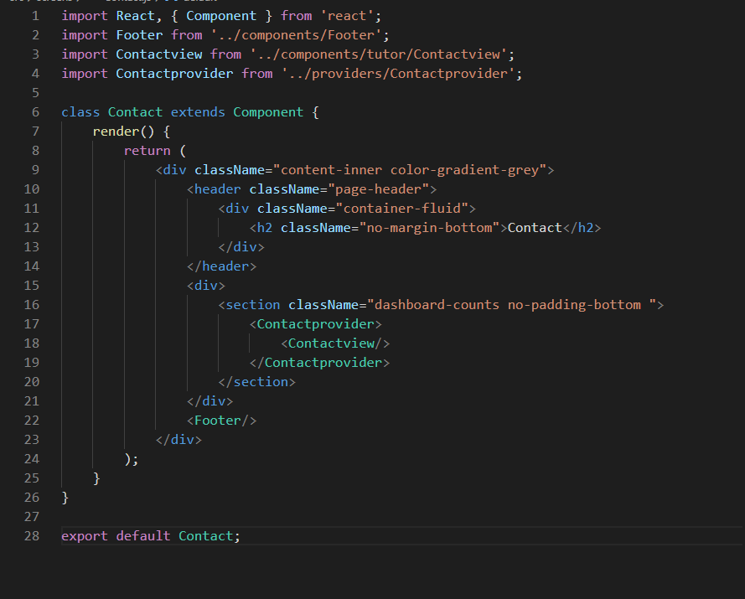

**Figure 47: React component class**

However, the difficulty is how to control the rendering of components according to the user's wishes. As a workaround, we used the react-router-dom library to manage the navigation whenever the user required to render the interface based on the navigation links.

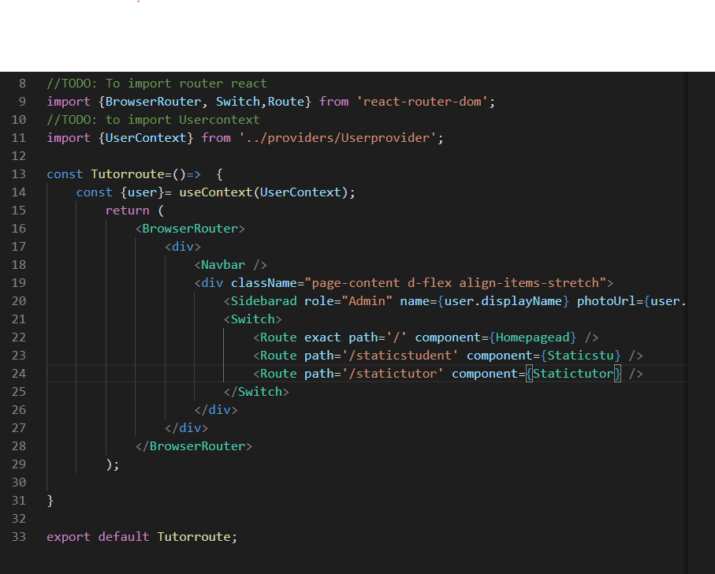

**Figure 48: React-router-dom**

Next is the backend part of the website, it is built based on firebase libraries and tools, including services such as authentication (login management), firestore (noSQL database), storage (locate files as images, videos....). In order to connect the website to these tools, we use firebase packages, also known as firebase SDK (Support develop Kit), along with the config file to the project's own address. For bellow example, we used the google authentication API login verification service provided by firebase. We can easily recognize that with only 8-9 lines of code, programmers can create a login function using the Google supplier's pop-up window. Programmers can avoid having to handle user account encryption and passwords in the database ... But ensure website security.

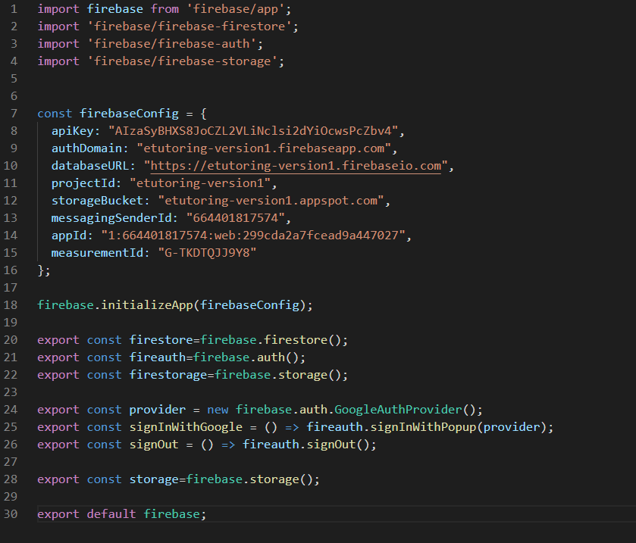

**Figure 49: Firebase SDK config**

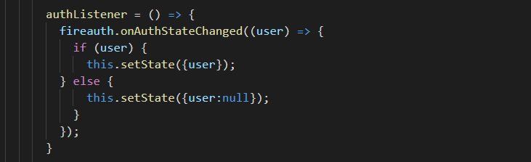

**Figure 50: Firebase authentication**

Similarly, throughout the project we can easily handle problems posed as storing user data in the form of a noSQL statement using firestore, or storing files in storage. Everything in the back-end is well supported by firebase.

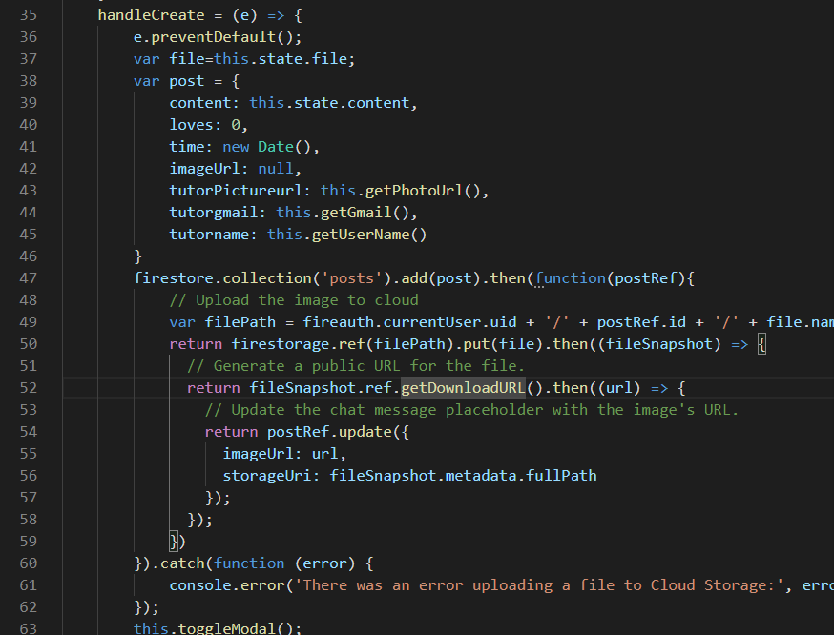

**Figure 51: Firebase storage and Fire store**

In the example above, to store information from the user's daily posting including the post's content, and the post's file. We used the Firestore to save fields such as content, love drop times, creation time, creator information, and image links to a collect as "posts." Each post will correspond to a document and they will be numbered. automatic and unique. Next the file will be storage in firebase storage, and the public URL in the Firestore for document file will be updated

# Scrum Document

In this report I will show you my understanding about Scrum Component. There are 3 main sections: People, Ceremonies and Artifact. However, as required, I will not cover all of their components, but their main characteristics. According to (Software Testing Help, 2020)

* **People (Team):**
* A typical Scrum team usually has 5-10 members with different functions creating a variety such as QA, Programmer, UI Designer, etc.
* Team members must work full time to exchange information and complete functions.
* Teams organize themselves and divide specific tasks together. In the process of working will often exchange and check progress.
* After each sprint is completed, team members can choose to change their work.
* **Ceremonies (Meeting):**
* **Sprint Planning Meeting:**
* Sections of the Sprint Planning meeting
* The first task when meeting is to identify the Sprint goals that the team needs to accomplish in the project.
* Target audience: Product owner, Scrum Master and Scrum Team
* Participants: The Scrum Master and the Scrum Team will be directly involved in the project development process
* Create a backlog Sprint
* **Sprint Review Meeting:**

In this section team members will present what they accomplished during the sprint stage. Usually, demos will show demos of new features or highlight difficulties encountered during implementation.

Meeting participants are Clients, Management, Product owner and Other engineers.

* **Sprint Retrospective Meeting:**

The team continued to discuss with three main questions about what work has been completed, what is continuing to be done and which work will start next. For example, in practice, when building a website, there are team members in charge of designing UI. then the content of the report will be yesterday, what features have been completed yesterday, what features will continue to be built today, and what are they intended to add in the future. After the individual reports can then synthesize information, evaluate the completion of the project.

* **Artifacts:**

According to (Adams, n.d.)

* **Product Backlog:**

We can understand that it is a list of all the work to be done in the project Often a combination of story-based work (online allows users to search and replace) and task-based work (improved exception handling Requirements for a system, expressed as one Priority list of backlog items Usually created in the Sprint Plan During the implementation of sprint backlogs can be changed and prioritized before each.

* **Sprint Backlog:**

In my personal opinion, the purpose that sprint backlogs is created to serve the achievement of the sprint goals that the team set when implementing a project.

* **Burn Down Chart:**

This is a tool to help honestly depict the total Sprint remaining time after each implementation day. In other words, it shows the estimated amount of time the team can complete the work to be done. Of course, in order for the project to achieve the best results, it is best for the team to speed up the time to complete the work because the process of implementing the activities is not always as desired, there are jobs that will not work. could be completed on time due to misjudgment of the difficulty level or encountering other objective problems that could take longer to complete. Therefore, we need to accelerate to complete other tasks to compensate for the extended time period. This helps to ensure that the system can be delivered on time.

# Apply The Scrum With Agile Method

## Product Backlog

At the request of the project, our team has divided the work to improve the functions of the system. But because we have neither experience nor knowledge, there are some functions that cannot be completed. So in this report I will show only the functions that the group has accomplished and show examples.

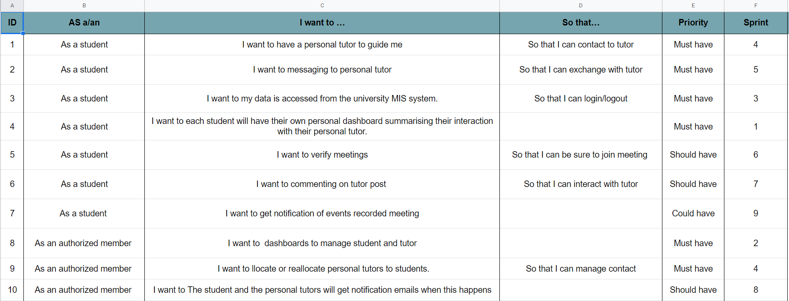

**Figure 52: Product Backlog Example**

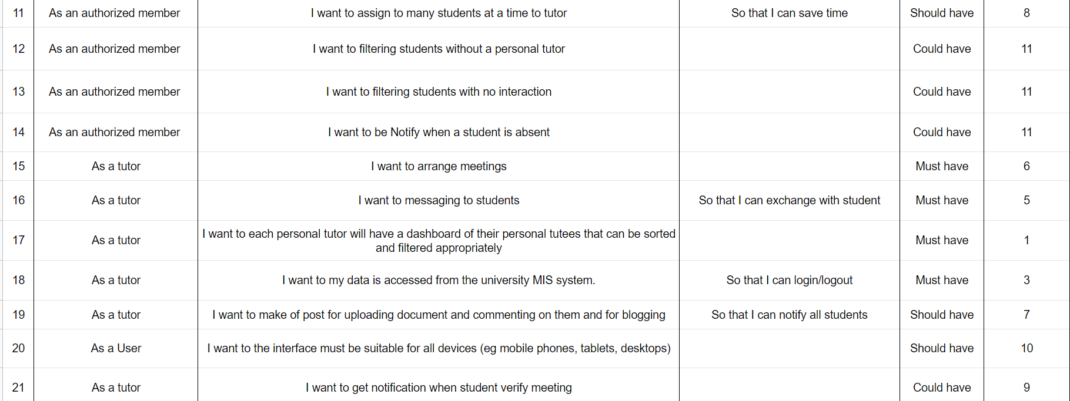

**Figure 53: Product Backlog Example**

As you can see in the table we have listed all the features that the system needs to ensure the needs of students, tutors and admin management. We also rely on the scrum model to divide the difficulty level for each task we need to perform. It is divided into three levels: Must have, should have and could have. Items rated as Must have and Should have will be prioritized by the priority group. As for the items in the have section, we will try to accomplish as much as we can and within time. After evaluating the priority for each task we will add it to the sprint according to the priority to complete the product.

## Daily Of The Meeting

In the next section, I will show you a list of the meetings that the group has done throughout the production process and the work the members perform as well as the difficulties we face to prove. that my team has followed the scrum model to finish out product.

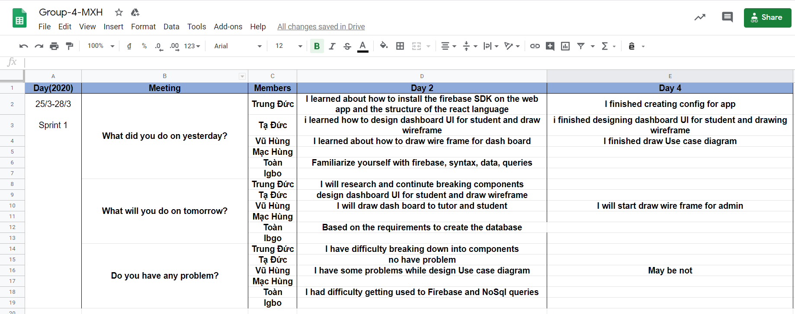

**Figure 54: Daily meeting in sprint 1**

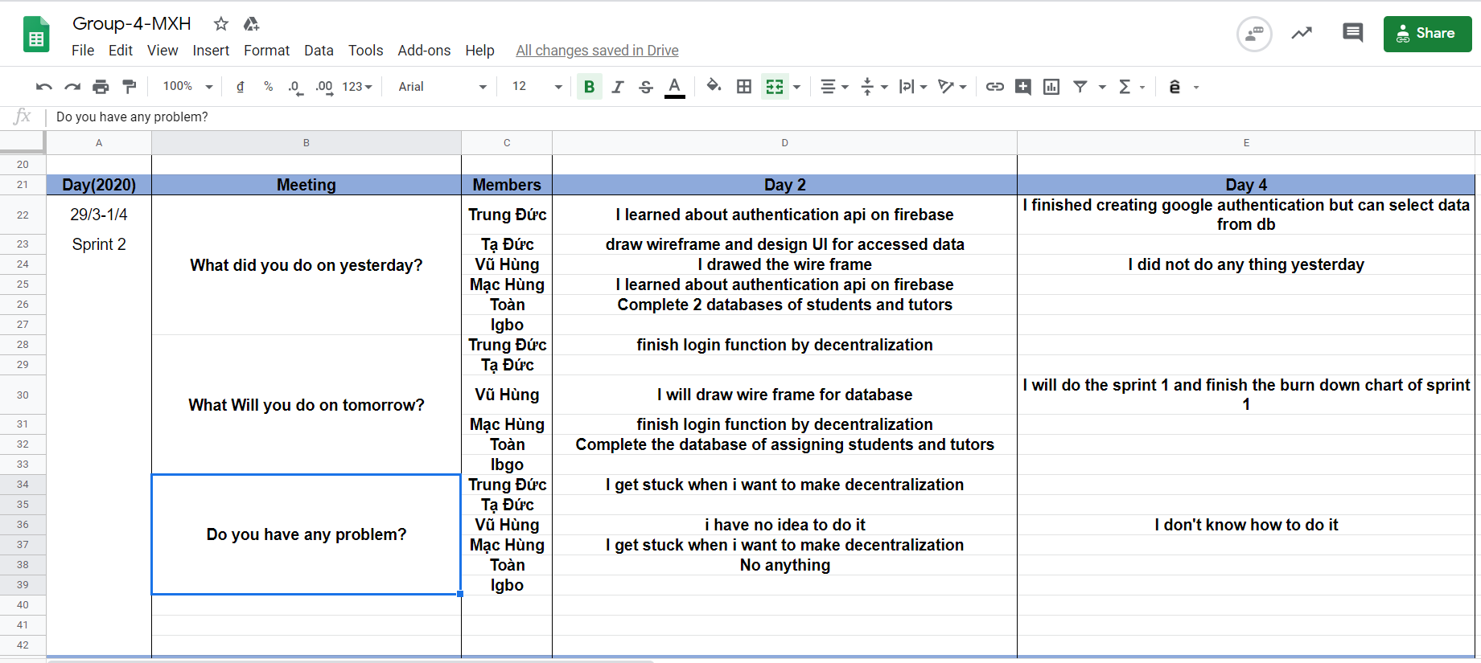

**Figure 55: Daily meeting in sprint 2**

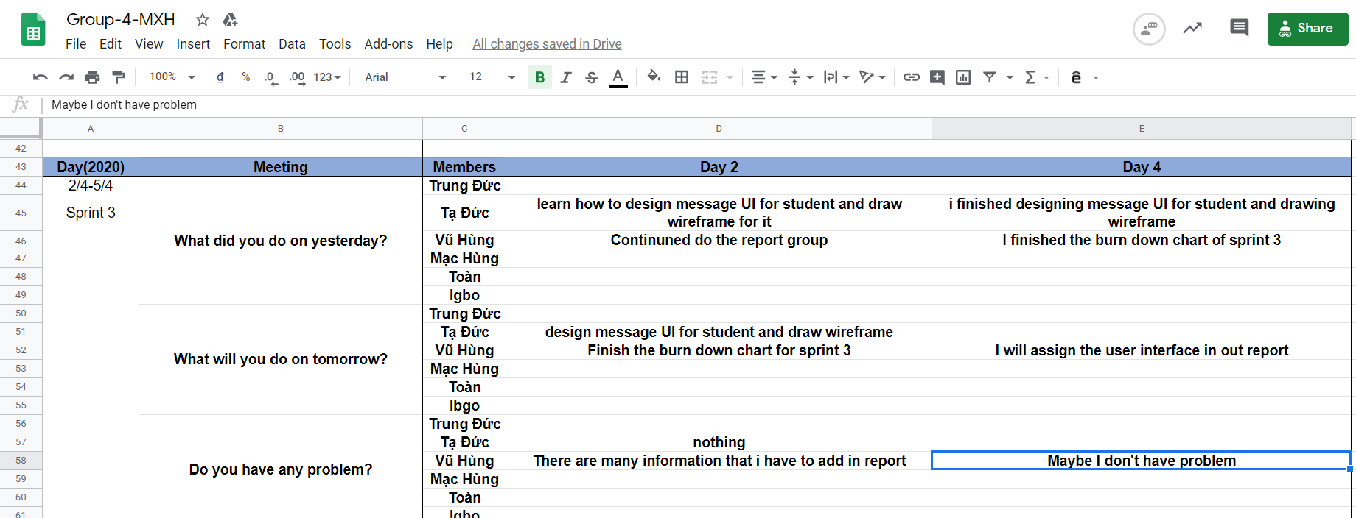

**Figure 56: Daily meeting in sprint 3**

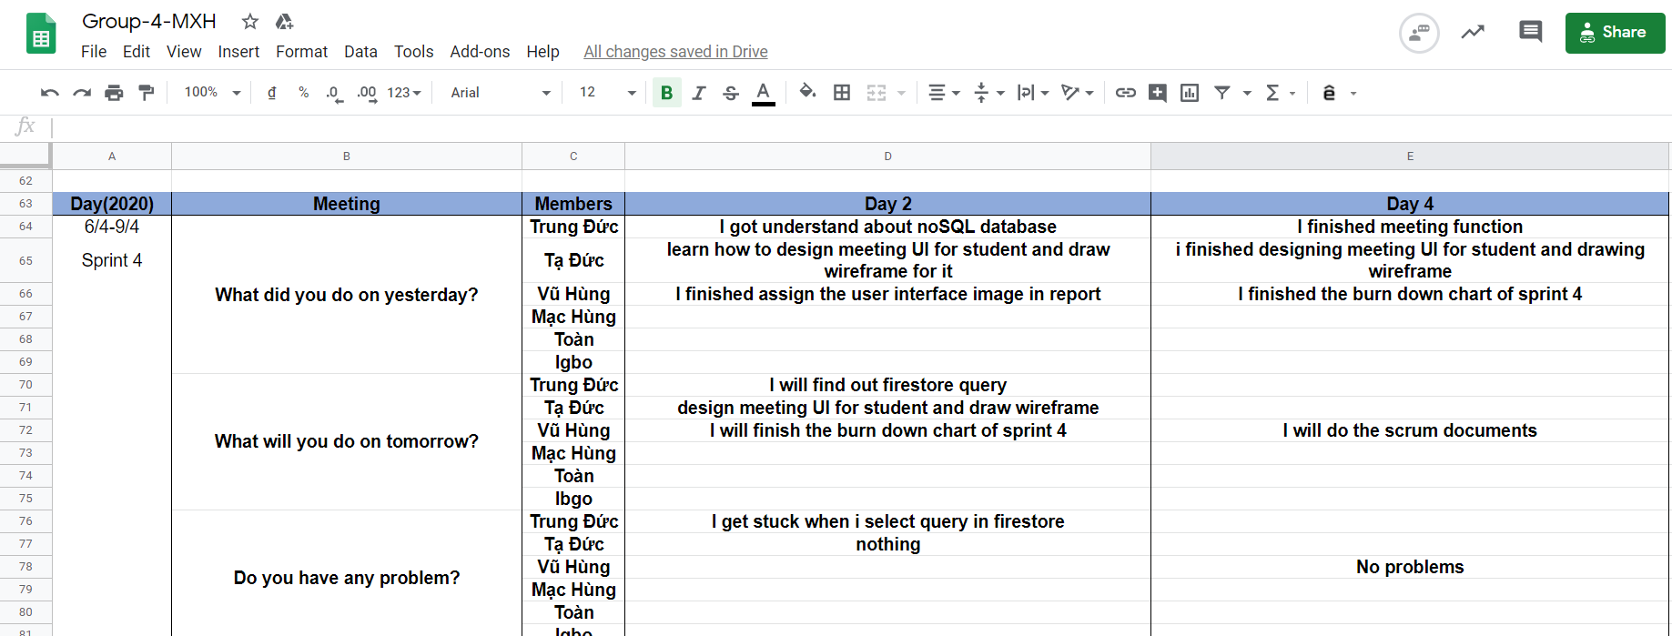

**Figure 57: Daily meeting in sprint 4**

* + - * Members design front - end create branch wireframe on Github
      * Add members to Firebase (User and permissions).
      * Adding documents in Trello.
      * Talk about types of meeting.
      * The members regularly update daily Sprint.

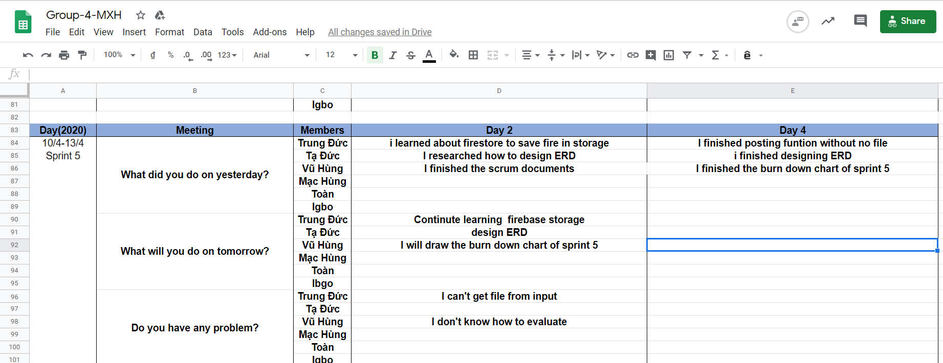

**Figure 58: Daily meeting in sprint 5**

* Members design front - end update wireframe on Github.
* Members agreed to set id for document in database.
* The members regularly update daily Sprint.

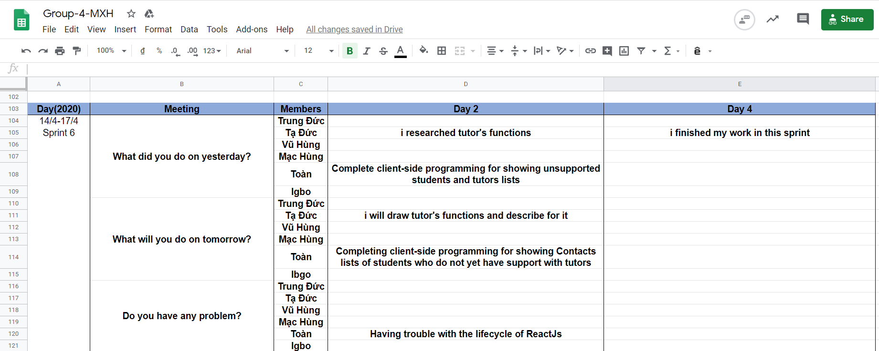

**Figure 59: Daily meeting in sprint 6**

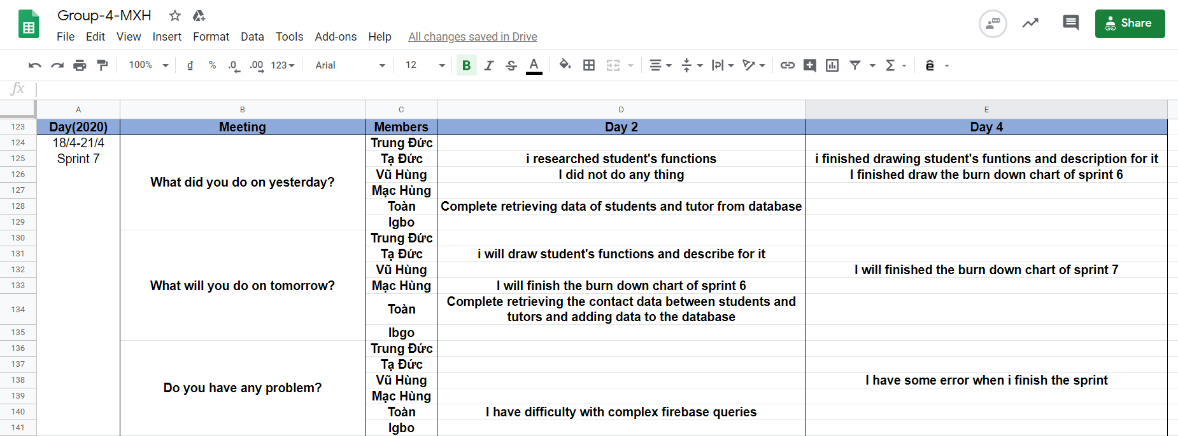

**Figure 60: Daily meeting in sprint 7**

* Members review the role of sprint, continue to complete the functionality that is not yet complete.
* Set goals for the week of completing the necessary functions.

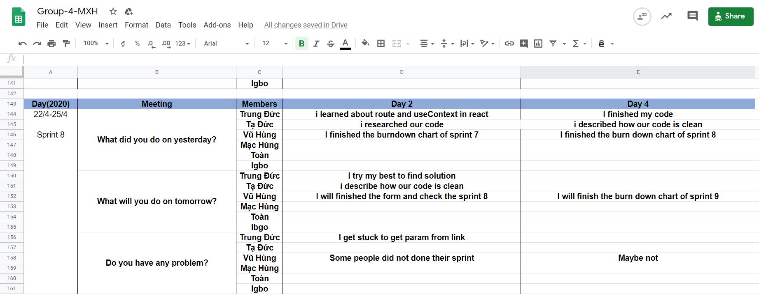

**Figure 61: Daily meeting in sprint 8**

Done postting can post photos that can like post. Not being able to render the posts according to the tutor's contact from the student's side, students cannot comment on the tutor's post, can't post other resources besides the image. In the near future, there will be a comment section below the post and additional documents!

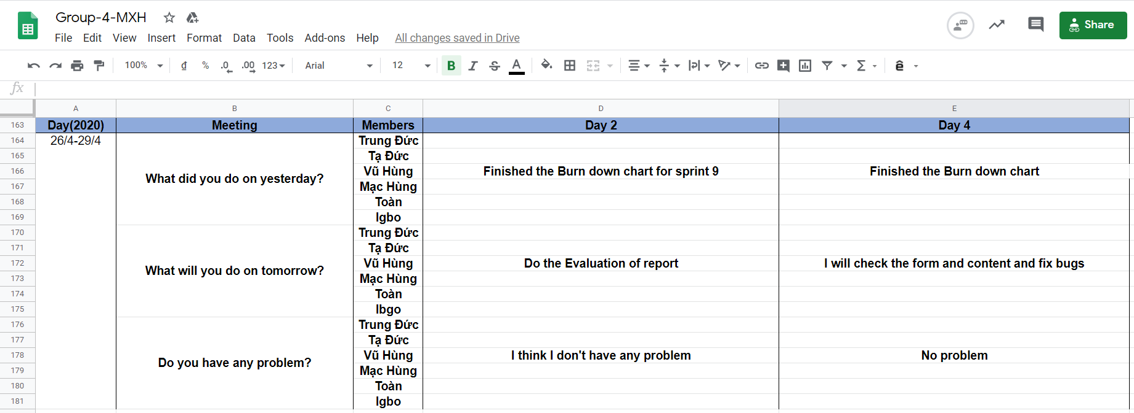

**Figure 62: Daily meeting in sprint 9**

The above is a summary of all the meetings of our team during the production process. We divided into 9 sprints and in each 4-day sprint we will meet twice, about 30 minutes each time for team members to talk and talk about what we have done today. first, what to do next and if there are any difficulties for the whole support team to overcome. During the meeting we also set out the next major goals that the group needs to accomplish. Some of the detailed examples have been listed above.

## Sprint Backlog

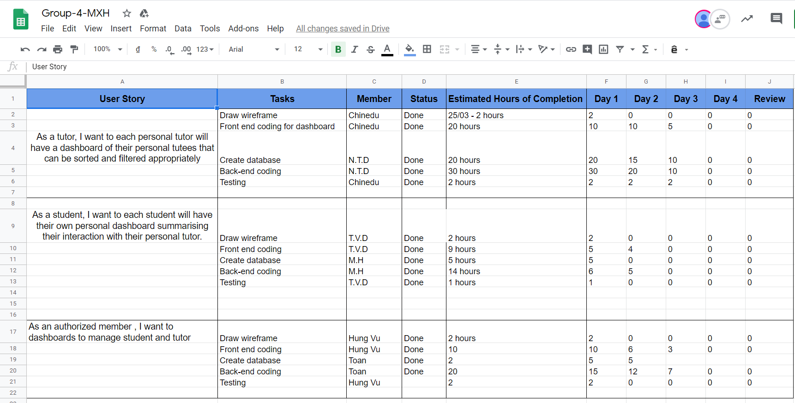

**Figure 63: Sprint 1**

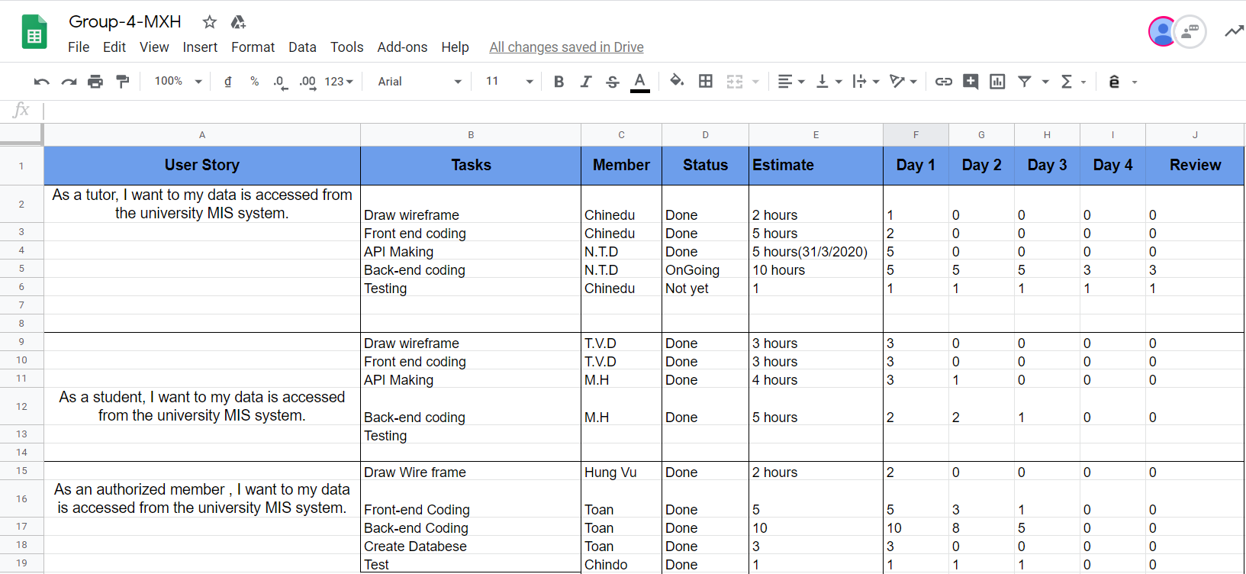

**Figure 64: Sprint 2**

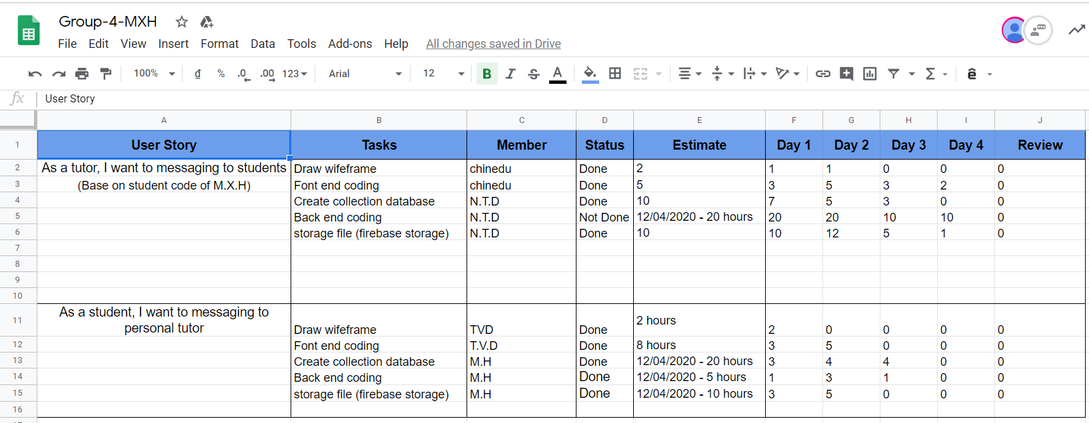

**Figure 65: Sprint 3**

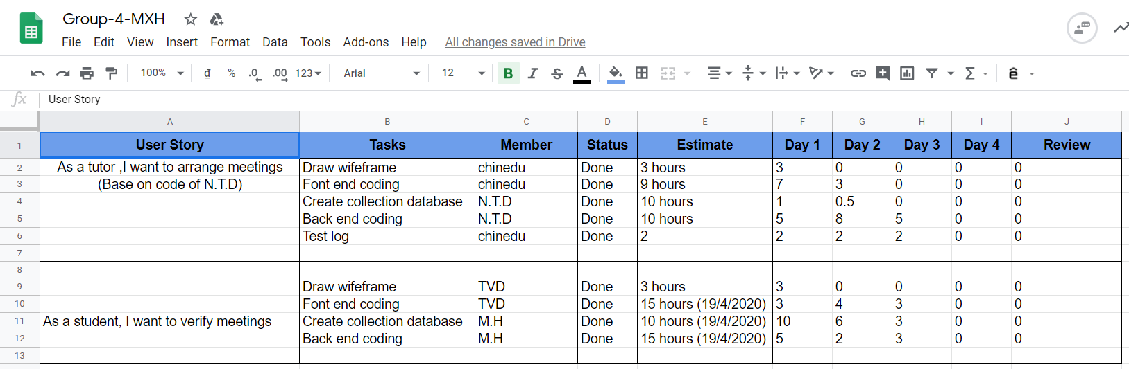

**Figure 66: Sprint 4**

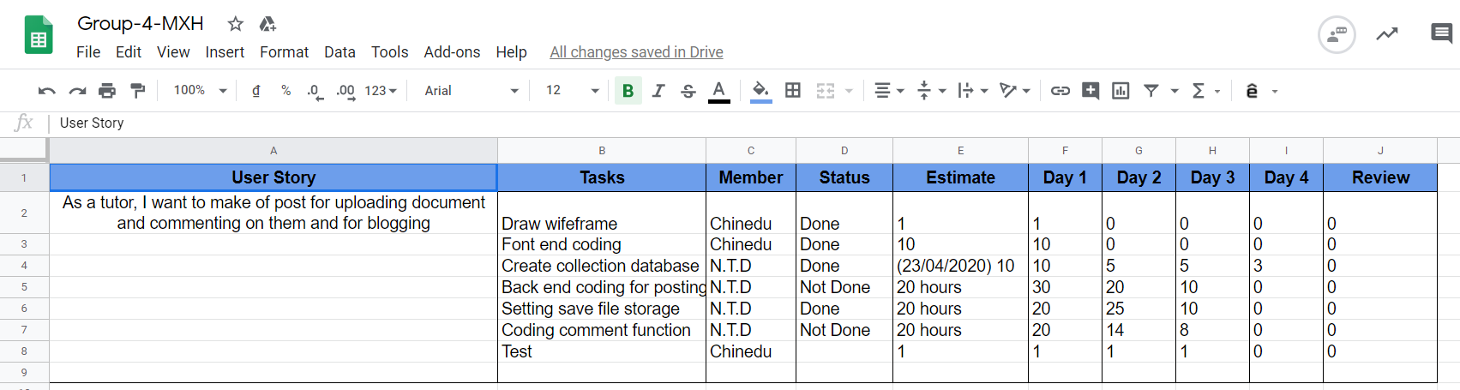

**Figure 67: Sprint 5**

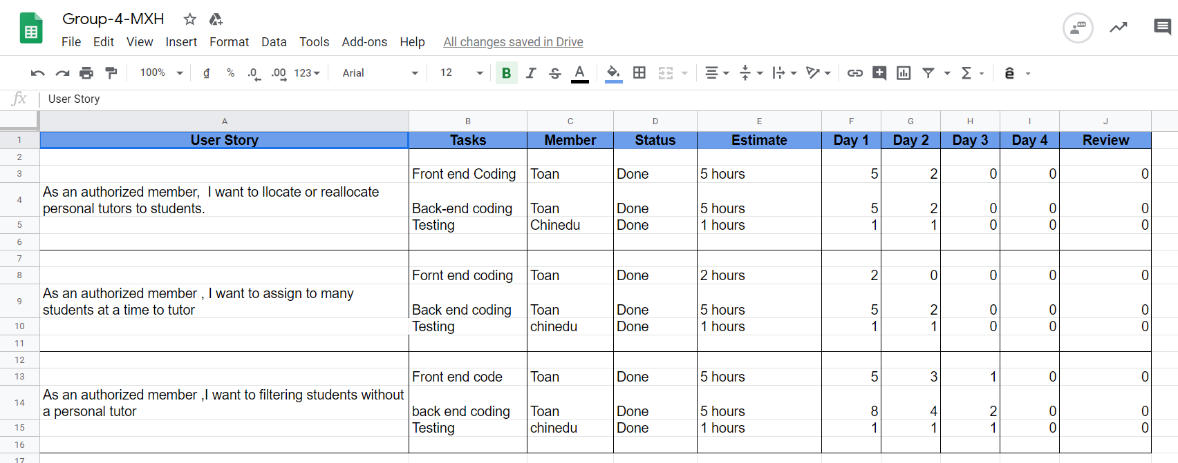

**Figure 68: Sprint 6**

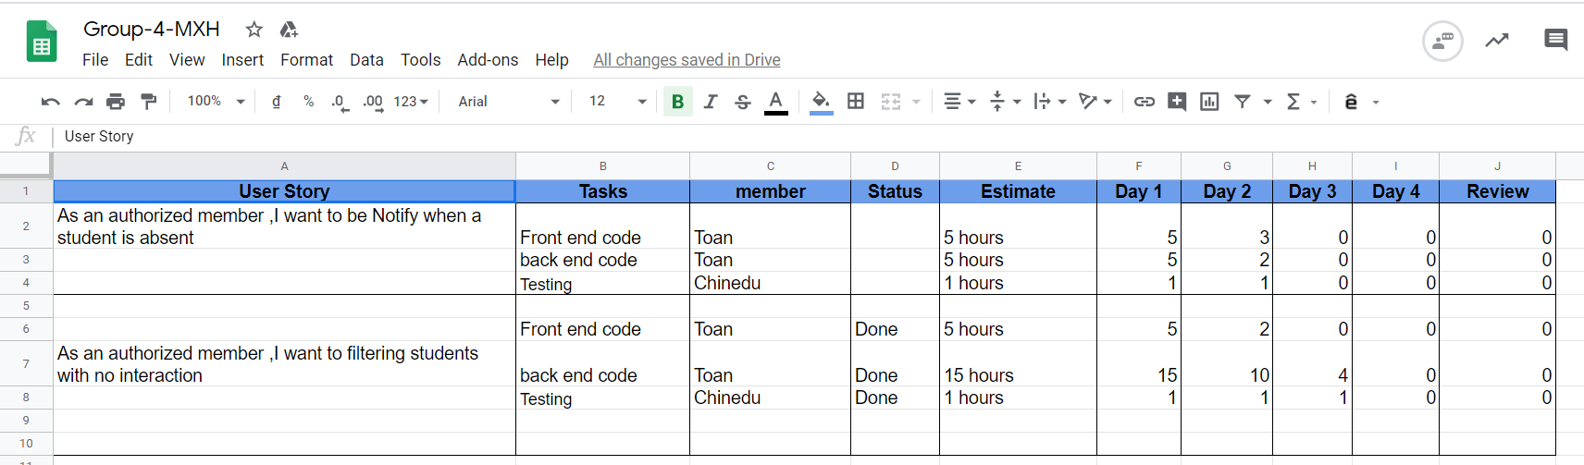

**Figure 69: Sprint 7**

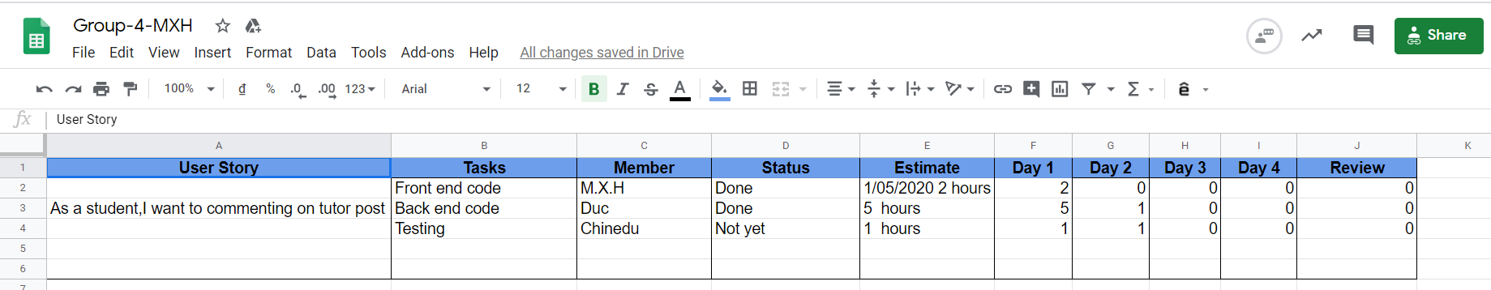

**Figure 70: Sprint 8**

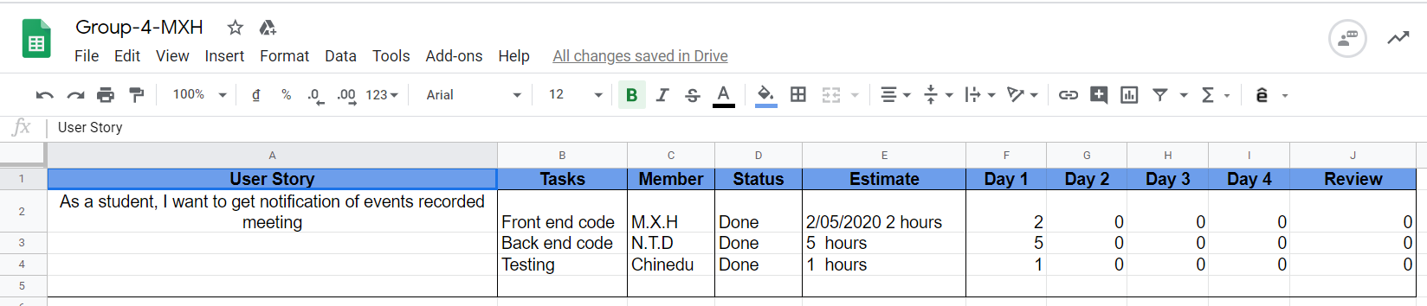

**Figure 71: Sprint 9**

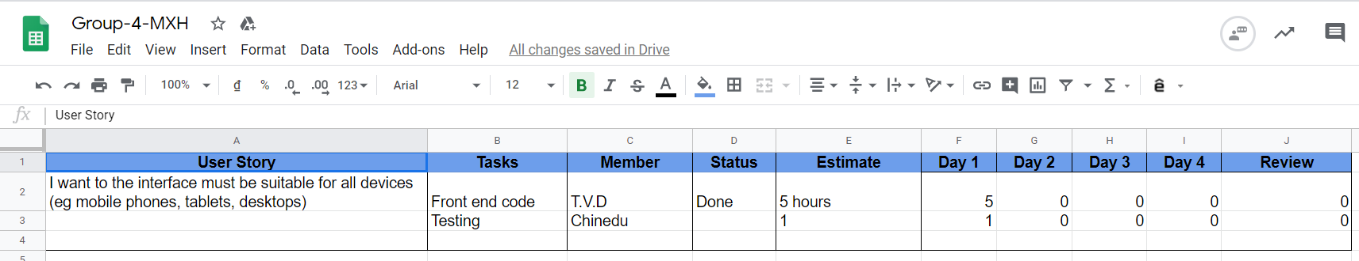

**Figure 72: Sprint 10**

Above are detailed photos of our team's sprint completion process. In these tables we list in detail the tasks that each member must do in sprint. It helps us know how much time we have spent on each job to monitor the completion of the product.

As you can see, most of the work is completed by the members on time. In the next section, there will be burn down charts that help us to evaluate the process as well as the timing.

## Burndown Chart

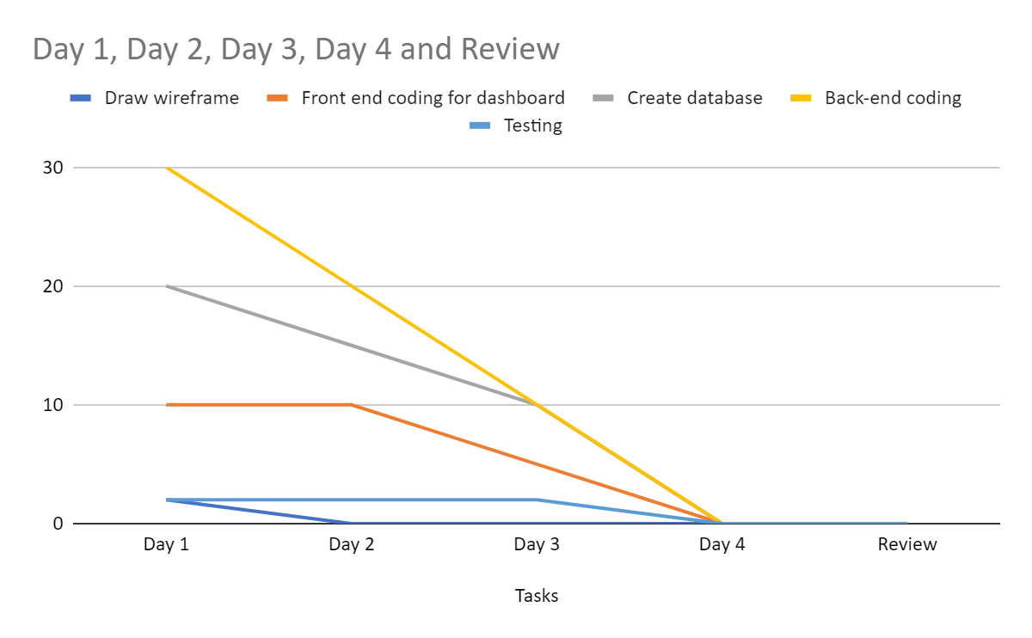

**Figure 73: Burn down chart of sprint 1**

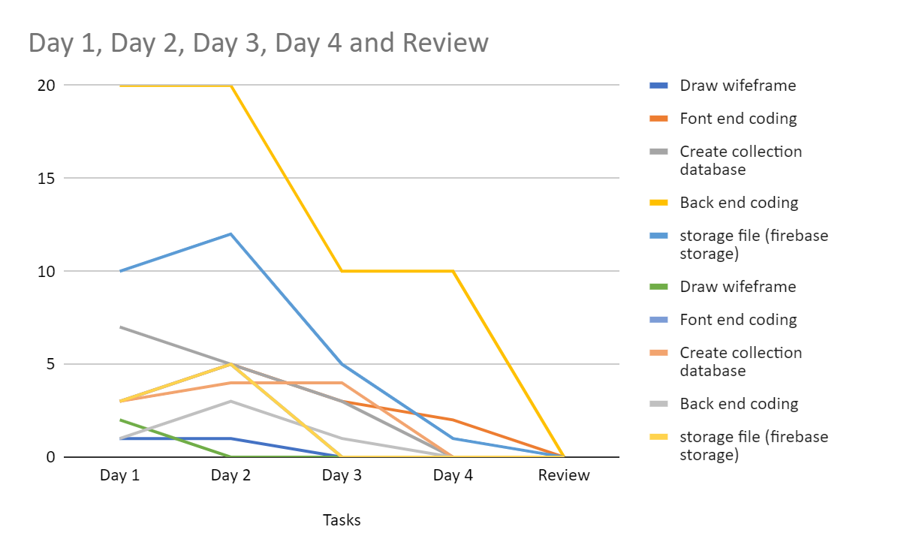

**Figure 74: Burn down chart of sprint 2**

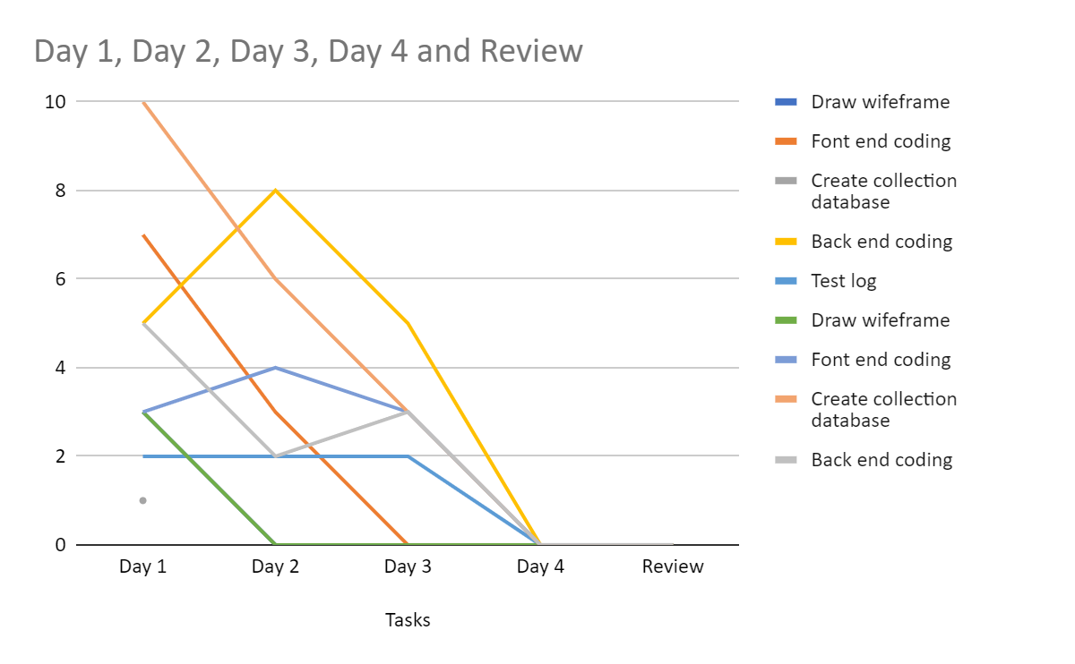

**Figure 75: Burn down chart of sprint 3**

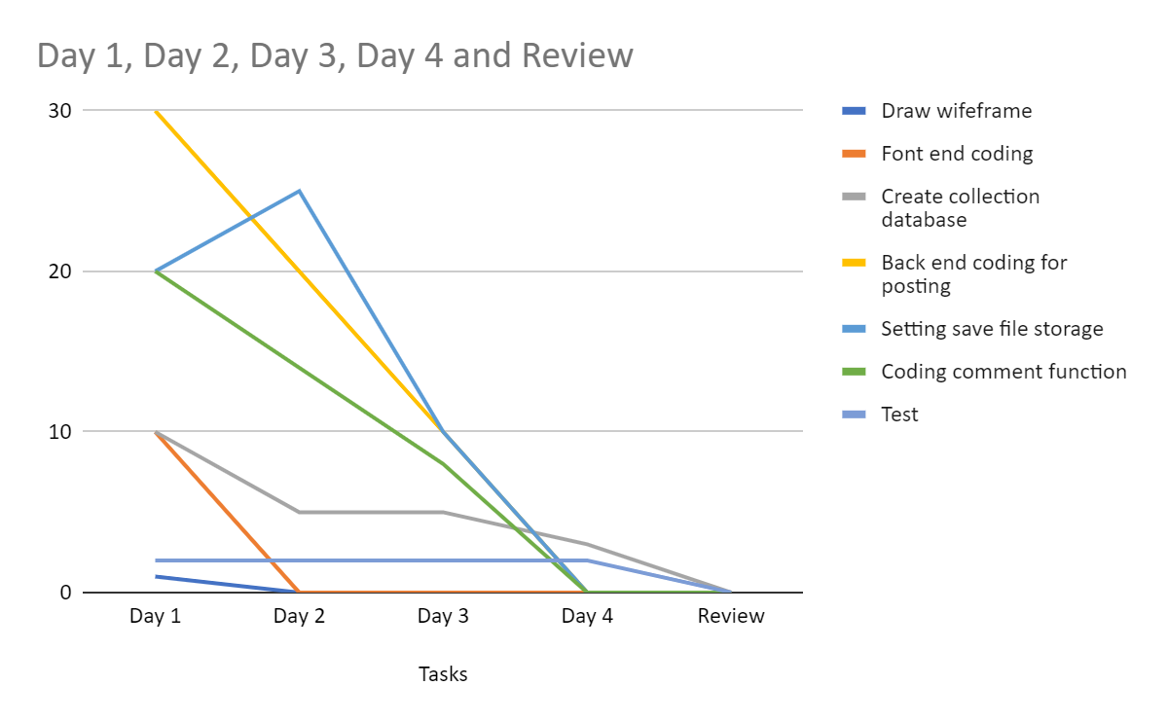

**Figure 76: Burn down chart of sprint 4**

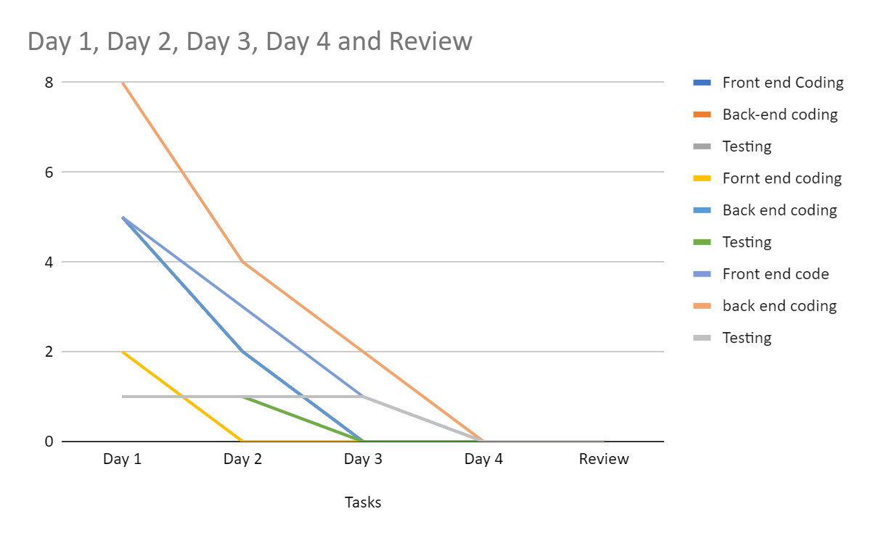

**Figure 77: Burn down chart of sprint 5**

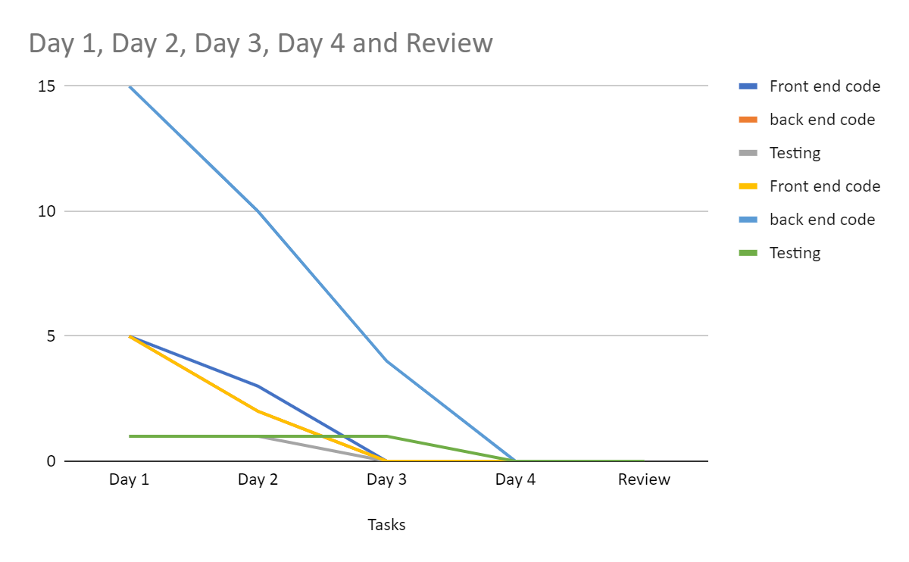

**Figure 78: Burn down chart of sprint 6**

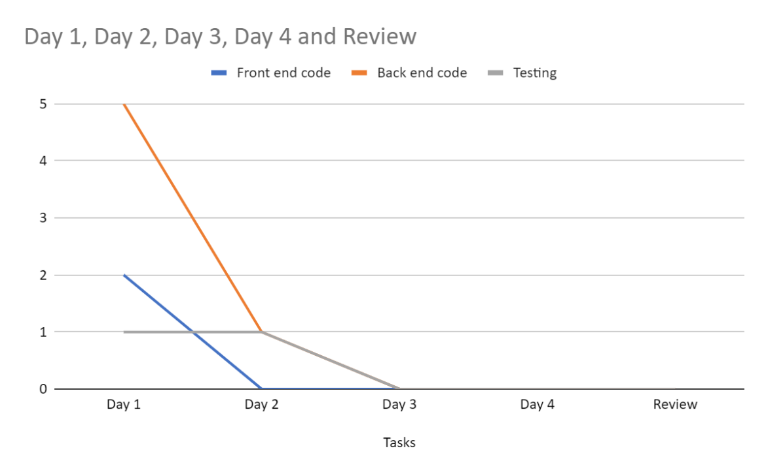

**Figure 79: Burn down chart of sprint 7**

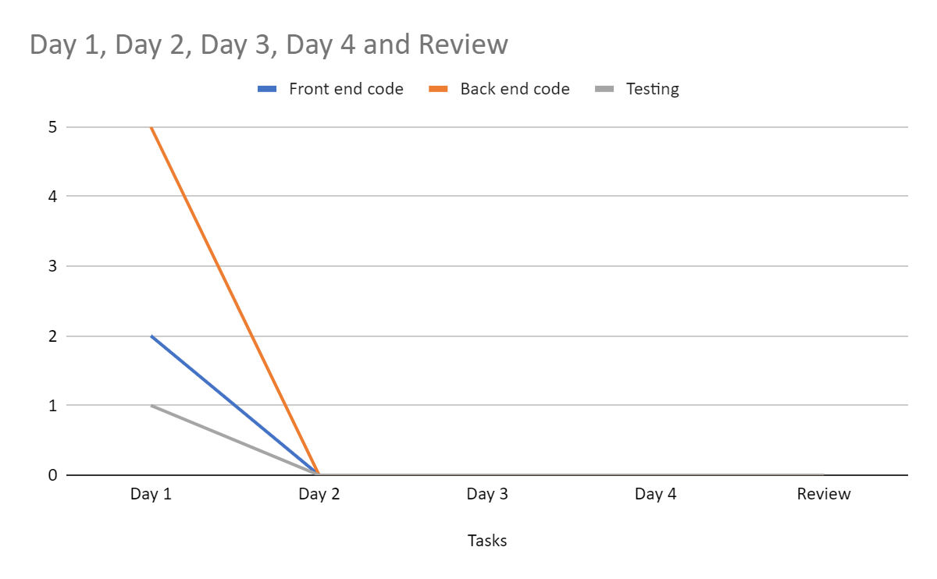

**Figure 74: Burn down chart of sprint 8**

The importance of burn down charts is undeniable to the process of building our web site. After completing one sprint we take the time to create a burn down chart. It gives us a better overview of what we have done and helps us to assess how much time our team has spent completing that sprint. This helps us assess whether we are on schedule or slowing down. If slow, we must take measures to complete the other sprint earlier to ensure progress with customers. Luckily we don't have any sprint over time. There have been times when the burn down chart has gone up, but we have made it in time to ensure that the product is on schedule.

# Testing

In this section, I will show hands-on experience and product reviews. In our team, there are 2 members in charge of testing the product so that we can evaluate if there are any bad areas that need to be improved or detect errors during use so we can fix them. before putting the product into the user's hands. Below I will show you some of the tests we have done on our products.

|  |  |
| --- | --- |
|  |  |

## Test Item

The website will be tested in localhost and in Kingsley’s computer.

## Test List of Function

The functions will be tested according to their roles and their various interface:

|  |  |  |
| --- | --- | --- |
| FUNCTIONS | ROLES | INTERFACE |
| Login | All the user | Log-in page |
| View the List of all the users | Admin | User list page |
| View the tutor profile and Student Profile | Admin, Tutor that is assign to a class, Student that is assign to that class | User profile page |
| View list of meeting | Admin | Meeting list |
| Edit user profile | Admin | Admin Dashboard |
| Assigning of tutor and student | Admin | Admin Dashboard |
| Tutor and student change | Admin | Admin dashboard |
| Add, update and delete meeting | Tutor | Tutor page |
| View the list of Meeting Post | Tutor, Student assigned to the meeting, Admin | Admin Dashboard |
| Add post and attaching of file | Tutor, Student assigned to the meeting | Tutor dashboard |
| Edit post in meeting | Tutor or the student that posted |  |
| Creating Schedule | tutor | Tutor Dashboard |
| Deleting Schedule | Tutor | Tutor Dashboard |
| Notification when a schedule is created, edited or deleted | Student in that meeting and tutor assigned | Student Dashboard |

**Pass / Fail criteria**

These criteria will be evaluated according to the actual to the actual result and will then be equated to the expected result.

|  |  |
| --- | --- |
|  |  |

## Test environment

Operating System: Window

Ram: 4 giga byte (Minimum)

Memory: 120 Giga bytes

IDE: Visual Studio code, Text Editor

Database:

Internet: Required

## Test Log:

**Login Test Log:**

**Test Scenario: Verify on entering an valid user id and password, the user can log in**

|  |  |  |  |  |  |  |
| --- | --- | --- | --- | --- | --- | --- |
| S/N | Step# | Step Details | Expected Result | Actual Result | Status | Date  tested |
| 1 | Login | Login with a registered google account | Log in | Log in | PASS | 02/05/2020 |
| 2 | Login | Login with an unregistered google account | Cannot log in | Cannot log in | PASS | 02/05/2020 |

**View dashboard Test case:**

|  |  |  |  |  |  |  |
| --- | --- | --- | --- | --- | --- | --- |
| S/N | Step# | Step Details | Expected Result | Actual Result | Status | Date tested |
| 3 | View Dashboard | Sign in with student account to view dashboard | Showing student information like, messages, meeting schedules, comment in a meeting, likes | Showing student information like, messages, meeting schedules, comment in a meeting, likes | PASS | 02/05/2020 |
| 4 | View Dashboard | Sign in with Tutor account to view dashboard | Showing Tutor information like, messages, creating meeting schedules, comment in a meeting, likes | Showing Tutor information like, messages, creating meeting schedules, comment in a meeting, likes | PASS | 02/05/2020 |
| 5 | List of student that have not been interactive | Sign in with Staff account to view student that have not been interactive | List of students that is not interactive for the past 7/28 days | List of students that is not interactive for the past 7/28 days | PASS | 02/05/2020 |
|  | List of student that without tutor | Sign in with Staff account to view student without tutor | List of students without tutor | List of students without tutor | PASS | 02/05/2020 |

**Check UI profile Test log:**

|  |  |  |  |  |  |  |
| --- | --- | --- | --- | --- | --- | --- |
| S/N | Step# | Step Details | Expected Result | Actual Result | Status | Date tested |
| 6 | Checking UI profile | Click on the profile page to view user information | Details of user information | User information not clear as it only shows the name | FAIL | 02/05/2020 |
| 7 | Checking UI profile | Click on the profile page to view user information | Details of the user information | User information clearly shows name and user information | PASS | 03/05/2020 |

**View all students Test Log:**

|  |  |  |  |  |  |  |
| --- | --- | --- | --- | --- | --- | --- |
| Sprint | Step# | Step Details | Expected Result | Actual Result | Status | Date  tested |
| 8 | View all students | View student name and email list of all students | All data are listed on a clear format: name and email | All student’s data was listed but the name and email was interchanged | FAIL | 03/05/2020 |
| 9 | View all students | View student name and email list of all students | All data are listed on a clear format: name and email | All student’s data was listed in the correct format: name and email | PASS | 04/05/2020 |

**View all Tutors test Log:**

|  |  |  |  |  |  |  |
| --- | --- | --- | --- | --- | --- | --- |
| S/N | Step# | Step Details | Expected Result | Actual Result | Status | Date Tested |
| 10 | View all Tutors | View all tutor from staff dash board | Displaying tutor information | A tutor listed in grid | PASS | 04/05/2020 |
| 11 | View all Tutors | View all tutors from student dashboard | Displaying Tutor assigned to the student | All tutors assigned is listed in a grid | PASS | 04/05/2020 |

**Assigning new Student to Tutor test log:**

|  |  |  |  |  |  |  |
| --- | --- | --- | --- | --- | --- | --- |
| S/N | Step# | Step Details | Expected Result | Actual Result | Status | Date  tested |
| 12 | Assign new tutors to student | Select a student from the list and allocate the student to a tutor | Assign successful | Assign successful | PASS | 04/05/2020 |
| 13 | Assign new tutors to student | Select a student from the list and relocate the student | Student relocated successful | Student can’t be relocated | FAIL | 04/05/2020 |
| 14 | Assign new tutors to student | Select a student from the list and change the tutor of the student | Tutor change successfully | Tutor can’t be changed | FAIL | 04/05/2020 |

**Search Student Test log:**

|  |  |  |  |  |  |  |
| --- | --- | --- | --- | --- | --- | --- |
| S/N | Step# | Step Details | Expected Result | Actual Result | Status | Date  tested |
| 15 | Search Student | Search for student in the search box with the correct email address | Search successful | No search box for student that already have a tutor | FAIL | 04/05/2020 |
| 16 | Search Student | Search for student in the search box that has no tutor | Search with student name | Search found | PASS | 04/05/2020 |

**Search Tutor Test log:**

|  |  |  |  |  |  |  |
| --- | --- | --- | --- | --- | --- | --- |
| S/N | Step# | Step Details | Expected Result | Actual Result | Status | Date  tested |
| 17 | Search Tutor | Search for Tutor in the search box with the correct email address or name | Search successful | Display the search ed tutor on the search result | PASS | 04/05/2020 |
| 18 | Search Tutor | Search for Tutor in the search box with an incorrect email | Search not found | Search not displays nothing on the search result | PASS |  |

**Create meeting Test log:**

|  |  |  |  |  |  |  |
| --- | --- | --- | --- | --- | --- | --- |
| S/N | Step# | Step Details | Expected Result | Actual Result | Status | Date  tested |
| 19 | Create meeting | Click on the plus sign at the top of the meeting activities in the tutor dashboard and select the title, content, start time, date and student information | Meeting created successfully | Adds a new meeting | PASS | 04/05/2020 |
| 20 | Creating meeting | Creating a meeting with an empty information | Error message | Adds a new meeting | FAIL | 04/05/2020 |

**Search meeting Test Log:**

|  |  |  |  |  |  |  |
| --- | --- | --- | --- | --- | --- | --- |
| S/N | Step# | Step Details | Expected Result | Actual Result | Status | Date tested |
| 21 | Search meeting | Search meeting by a particular key word. E.g. search by title | Find the meeting searched by Title | No search option | FAIL | 04/05/2020 |
| 22 | Search meeting | Search meeting by an invalid search format. E.g. search by student name | Invalid search format, search not found. | No search option | FAIL | 04/05/2020 |

**Edit meeting Test Log:**

|  |  |  |  |  |  |  |
| --- | --- | --- | --- | --- | --- | --- |
| S/N | Step# | Step Details | Expected Result | Actual Result | Status | Date  tested |
| 23 | Edit meeting by changing the date and the time | Select date and time and select edit to change the date and time | Meeting updated successfully | Meeting created can’t be edited | FAIL | 04/05/2020 |
| 24 | Edit meeting by changing the date and the time | Select datetime less than the require datetime | Error message: invalid datetime | Meeting created can’t be edited | FAIL | 04/05/2020 |

**View all meeting Test Log:**

|  |  |  |  |  |  |  |
| --- | --- | --- | --- | --- | --- | --- |
| S/N | Step# | Step Details | Expected Result | Actual Result | Status | Date  tested |
| 25 | ‘View all meeting’ | View all the meeting that the user had created | Display all the meeting | Displays list of meetings | PASS | 04/05/2020 |

**Uploading file on meeting Test Log:**

|  |  |  |  |  |  |  |
| --- | --- | --- | --- | --- | --- | --- |
| S/N | Step# | Step Details | Expected Result | Actual Result | Status | Date tested |
| 26 | Upload file | ‘Choose an file with a correct file format and upload on the daily post | Uploaded successful | File uploaded | PASS | 04/05/2020 |
| 27 | Upload file | ‘Choose a file with an incorrect file format and upload on the daily post | Error message: incorrect file format | File uploaded successfully | FAIL | 04/05/2020 |

**Tutor Comment on meeting Test Log:**

|  |  |  |  |  |  |  |
| --- | --- | --- | --- | --- | --- | --- |
| S/N | Step# | Step Details | Expected Result | Actual Result | Status | Date tested |
| 28 | Comment in a Daily post | Comment with a tutor on a daily post | Comment sent and received | Tutor comments successfully on a daily post | PASS | 04/05/2020 |

**Student Comment on meeting Test Log:**

|  |  |  |  |  |  |  |
| --- | --- | --- | --- | --- | --- | --- |
| S/N | Step# | Step Details | Expected Result | Actual Result | Status | Date tested |
| 29 | Comment in a meeting | Comment with a student on a meeting | Comment sent and received | Student comments successfully on a daily post | PASS | 04/05/2020 |

**Notification received on Meeting created Test Log:**

|  |  |  |  |  |  |  |
| --- | --- | --- | --- | --- | --- | --- |
| S/N | Step# | Step Details | Expected Result | Actual Result | Status | Date tested |
| 30 | Receive a notification when a meeting is created or change | Check the message on the message icon to reveal the content | Meeting created message stating the correct date and time with the correct content and | Meeting is created but the notification icon didn’t reveal the content | FAIL | 04/05/2020 |

**Chat Test Log:**

|  |  |  |  |  |  |  |
| --- | --- | --- | --- | --- | --- | --- |
| S/N | Step# | Step Details | Expected Result | Actual Result | Status | Date tested |
| 31 | chat | Click on the chat icon from the student and send message to the tutor | Message send and receive from Student to tutor | Message sent to tutor | PASS | 04/05/2020 |
| 32 | Chat | Click on the chat icon from the Tutor and send message to the student | Message send and receive from Student to tutor | Message sent to student | PASS | 04/05/2020 |
| 33 | Chat | Click on the chat icon from the Tutor or student and send a message without any content | The send button will not be operational. | Message sent | FAIL | 04/05/2020 |
| 34 | Chat | Click on the chat icon from the Tutor or student and send a message without any content | The send button will not be operational. | Message Sent | FAIL | 04/05/2020 |

## Test case summary

* **Number of case tested: 34**
* **Number of test cases passed: 21**
* **Number of test cases failed:13**
* **Number of test cases solved: 0**

In this test, when we build a web site, we also perform the test every time a sprint is completed. At the beginning, we encountered a lot of errors when performing the test. Then the whole group will meet and find ways to fix the errors to improve the product. So you can see in our test log diagram that there are quite a few failures. However, although we tried hard, but at the end of the project, we still could not fix all the errors that appeared in the system but most of the main functions required by the course work were completed and tested. work. If we have more time, we will be able to improve the system to minimize errors and create the best user experience.

In the next section, my general assessments of the entire system as well as the group report completion process.

# Summary

In summary, in this group report we have covered the whole process of our team completing the construction of websites to support tutors and E-tutor students. We conducted a requirement analysis to determine the course work course requirements to best meet the user's requirements. Use case diagrams, Erd has also been deployed to serve the website creation process. Next, we have built wire frames for each user type and their specific functions so that when implementing the interface code, it will be easier to implement. After completing the site, we showed photos of user dash boards and functions to prove we have made those features.

The other part is how we show the security of our system, how we interact with the Google API, how the Fire base security works, and both Functional requirements and Non-functional requirements. We also explain the code of important system functions like login, react-router-dom, etc. And we have also implemented clean code to increase the aesthetics. And we also show our findings about the MVC model to prove that we understand the methods we use.

In the next we also provide evidence that we have applied the Scrum model to our project. We have shown the general analysis and evaluation of the priority of each requirement and put them into each sprint according to priority. At each sprint we create a Daily meeting table to discuss what has been done and see if there are any difficulties that need to be addressed. The Product Backlog and Burn down chart have also been used to statistically and align website completion time in line with the deadline set by customers.

In the last part is a summary of the test results our team performed during the construction of the web site. It is the basis for us to detect system errors and be able to fix them in the shortest time.

However, there are still some limitations such as we still have a lot of errors in the system and cannot complete all the features that the course work out. The process of applying Scrum to website building has not been good. More detailed reviews and personal comments will be presented in the individual report. Thank you for reading our report and wish you have a nice day.

# References

(n.d.). Retrieved from https://firebase.google.com/docs/auth

Adams, S. (n.d.). *Computing & Mathematical Sciences*. Retrieved from https://drive.google.com/file/d/1rDVJ6czIU2tS4evxW9o8A0M721lNu_xX/view

*Software Testing Help*. (2020, 04 22). Retrieved from https://www.softwaretestinghelp.com/agile-scrum-methodology-for-development-and-testing/